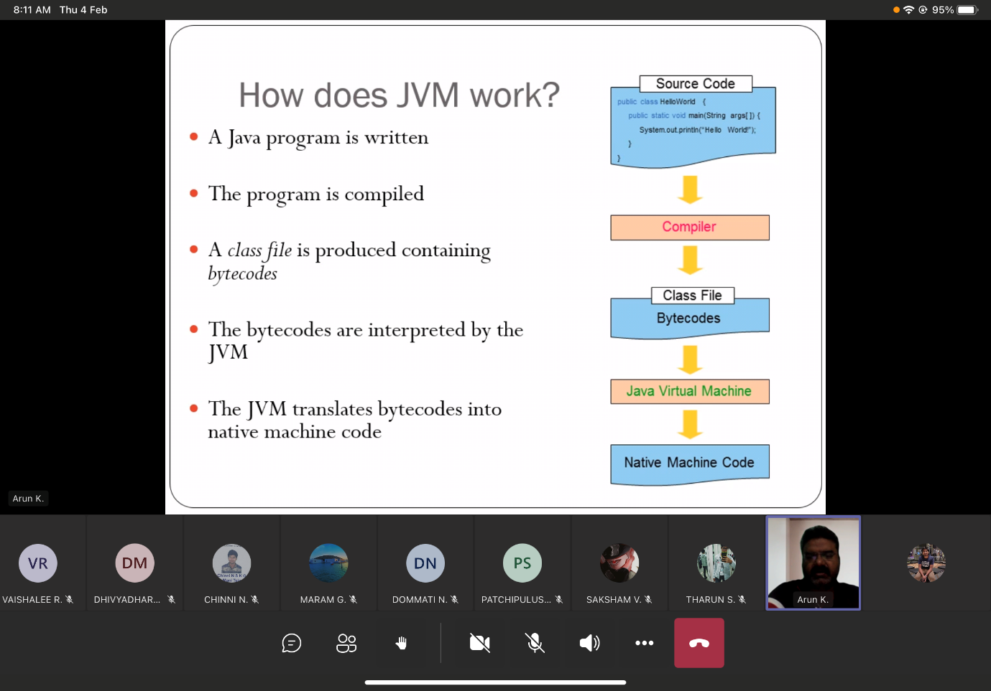

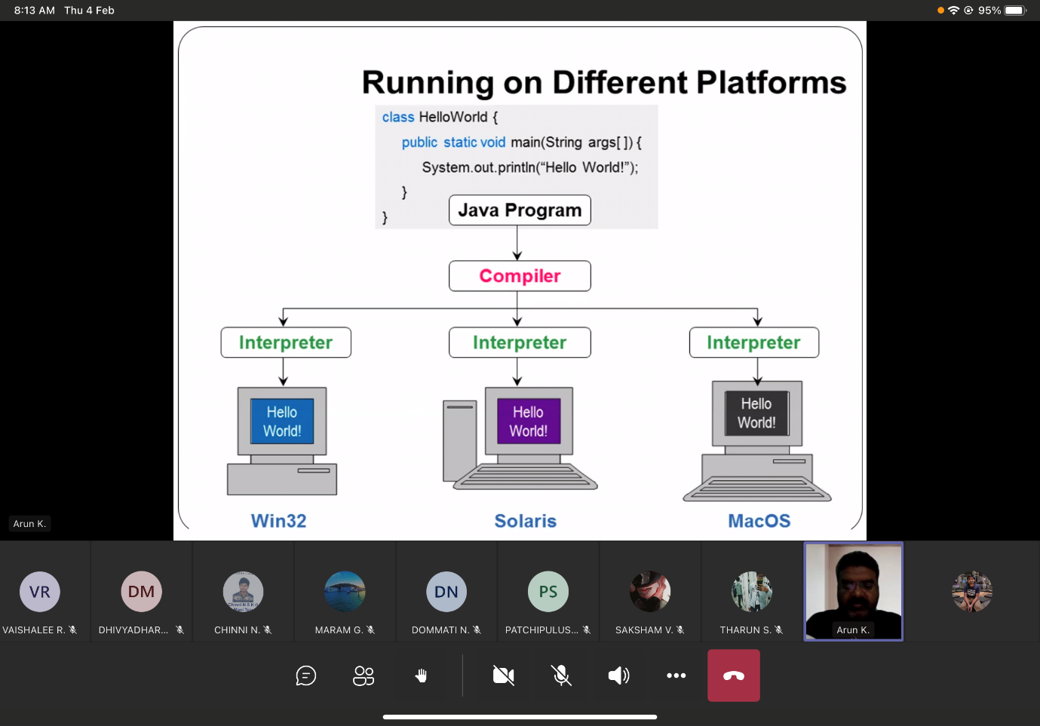

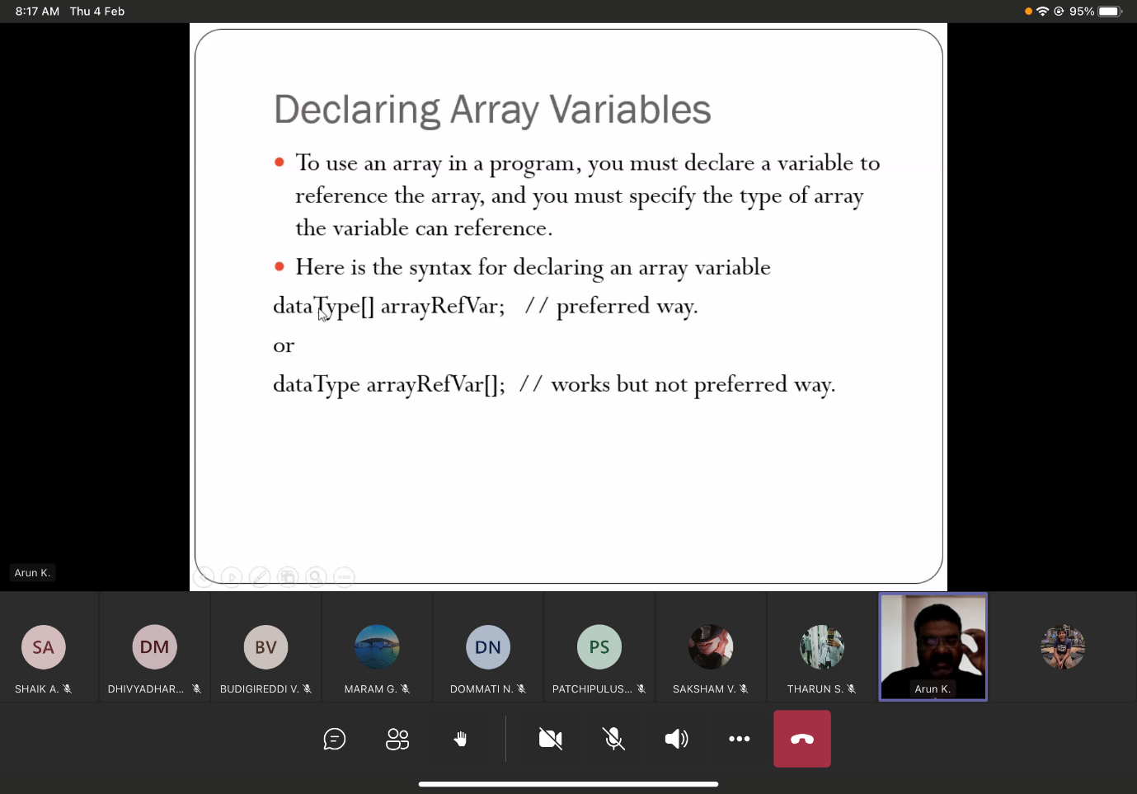

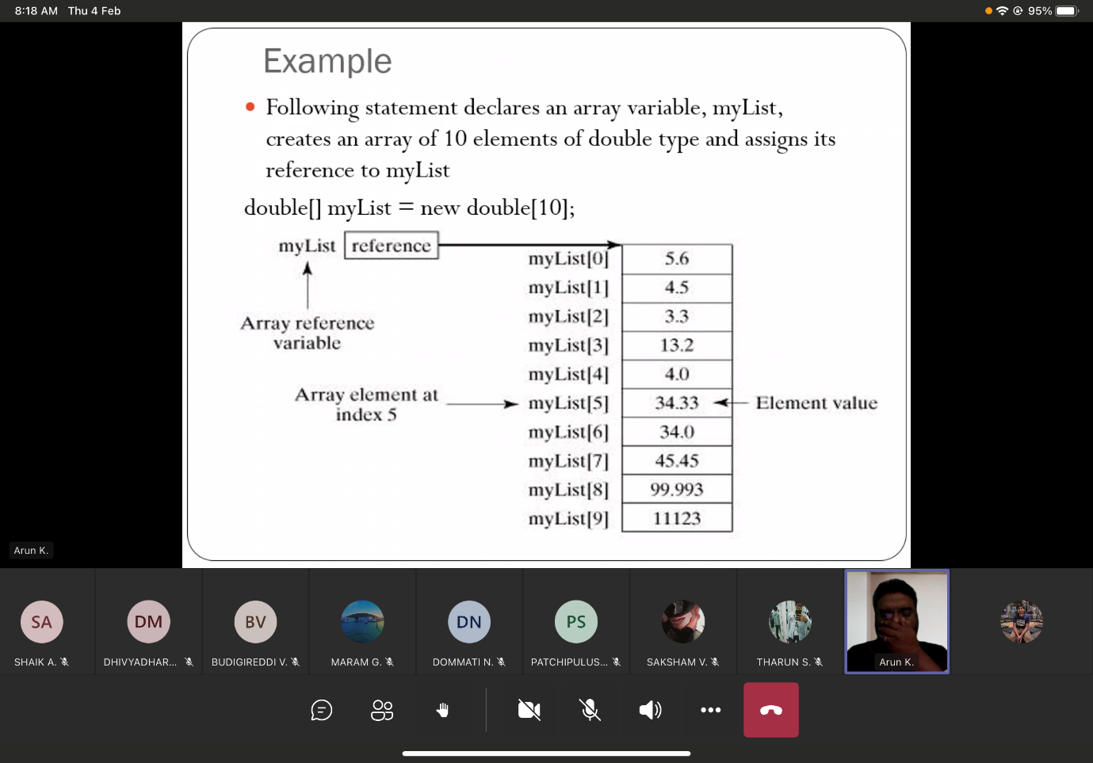

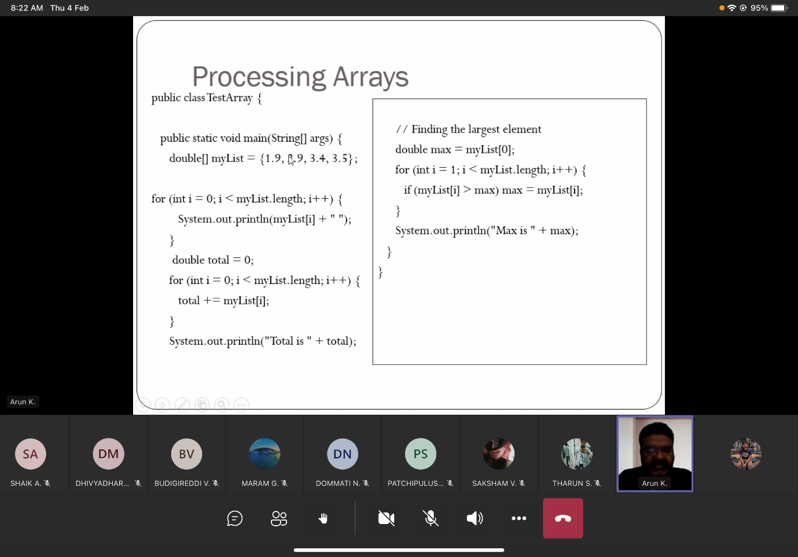

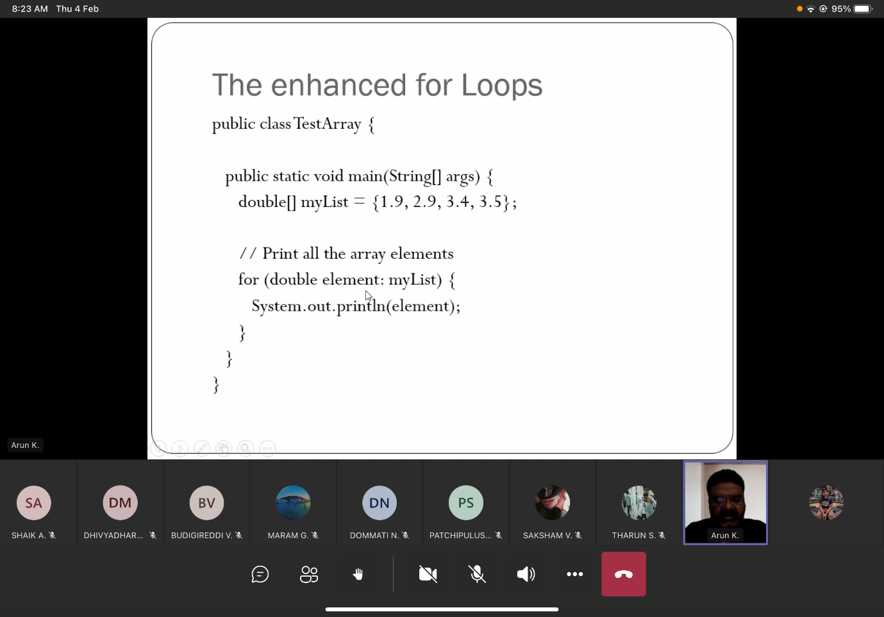

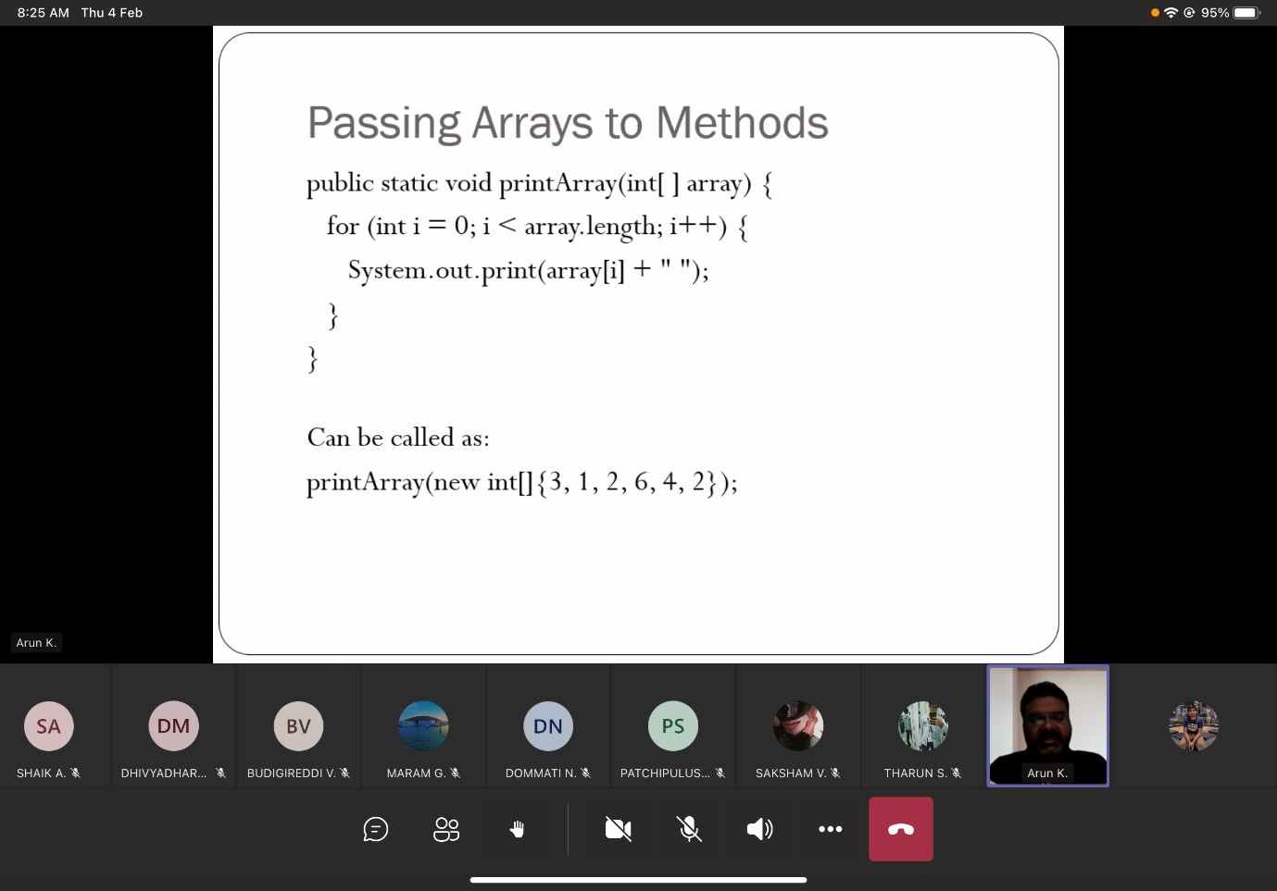

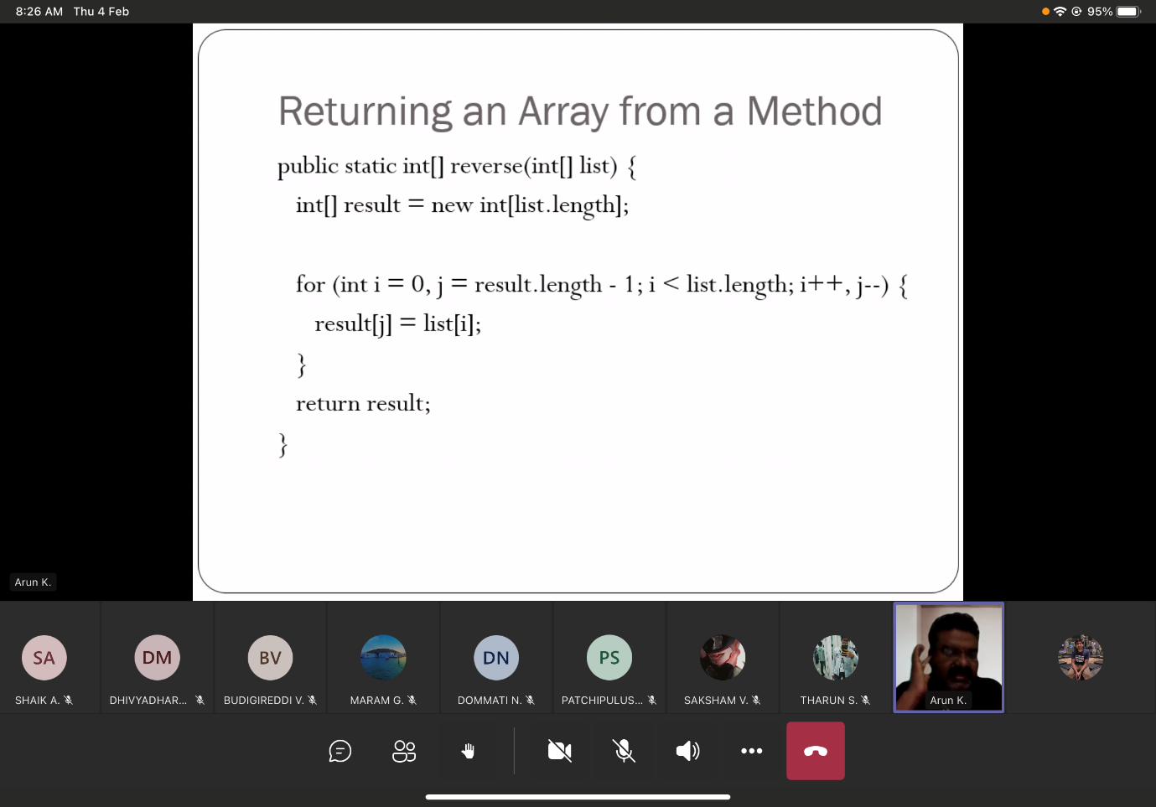

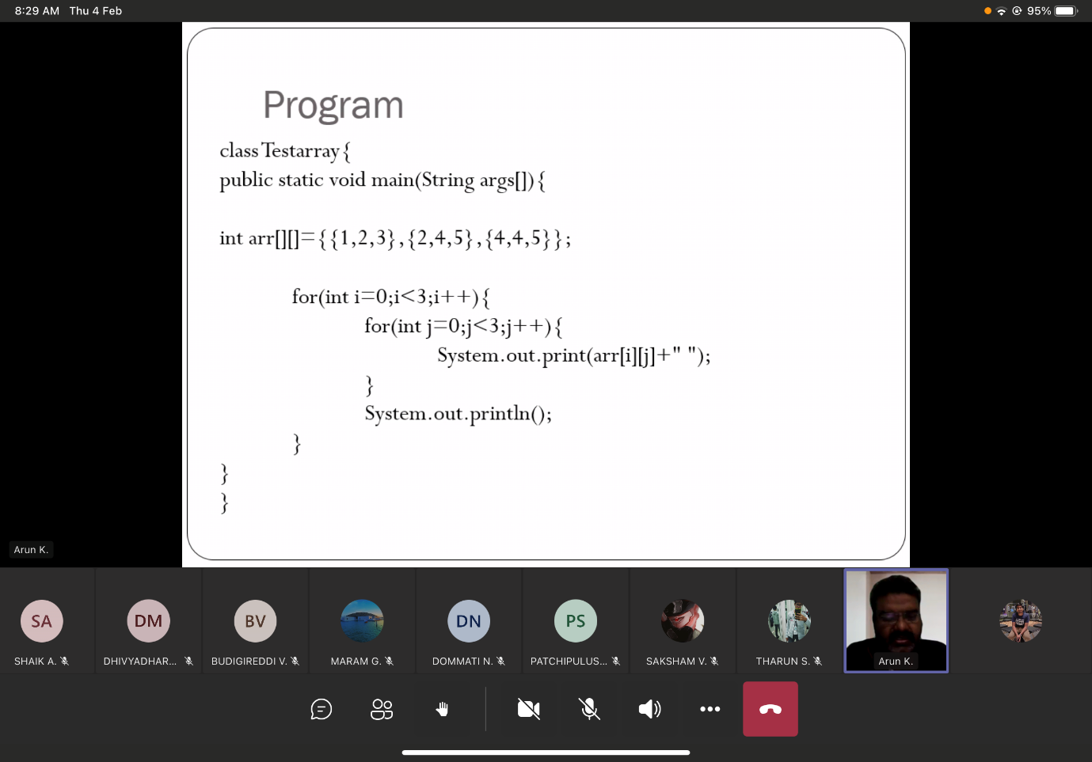

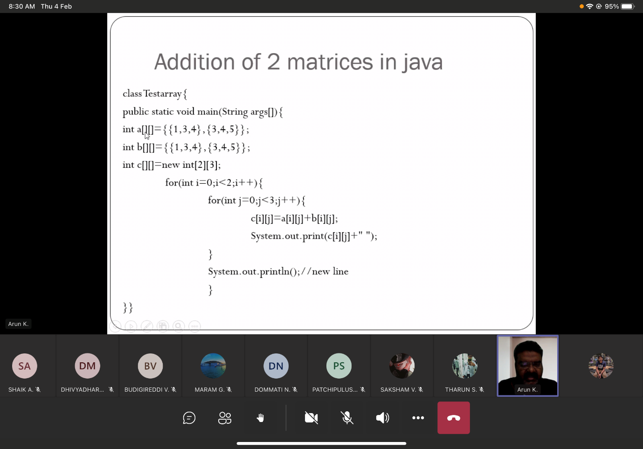

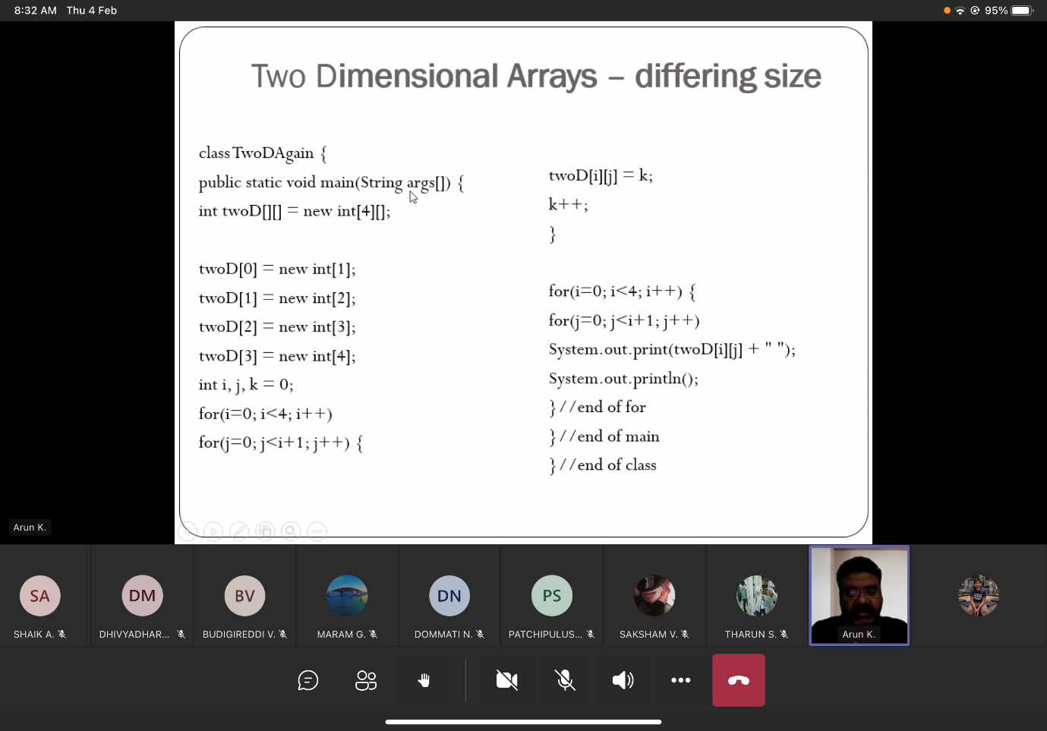

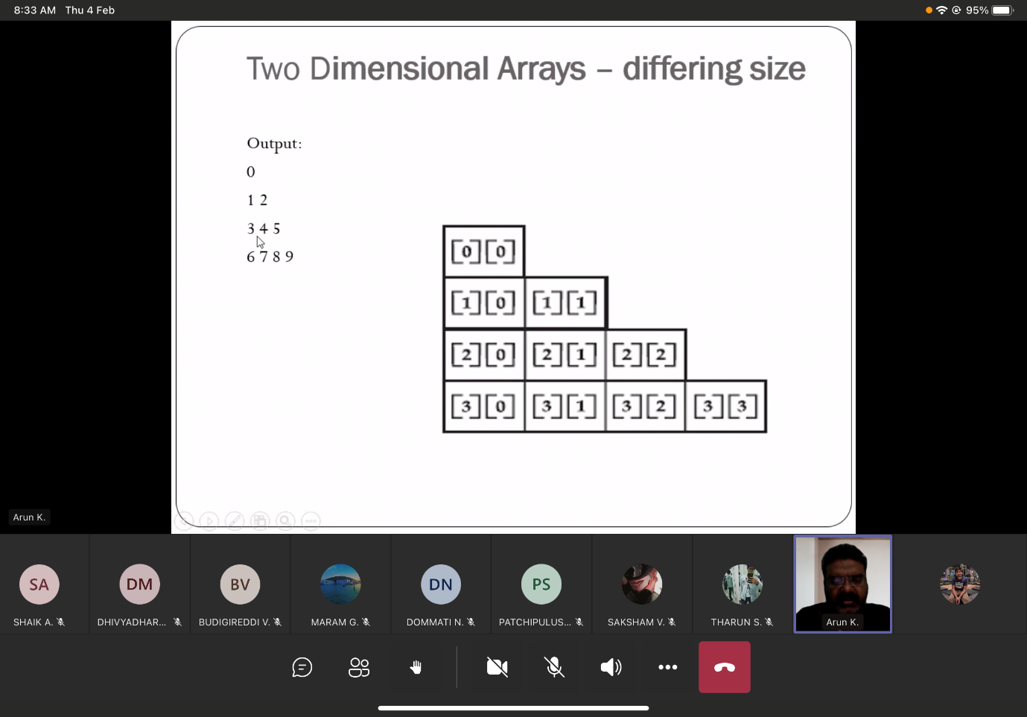

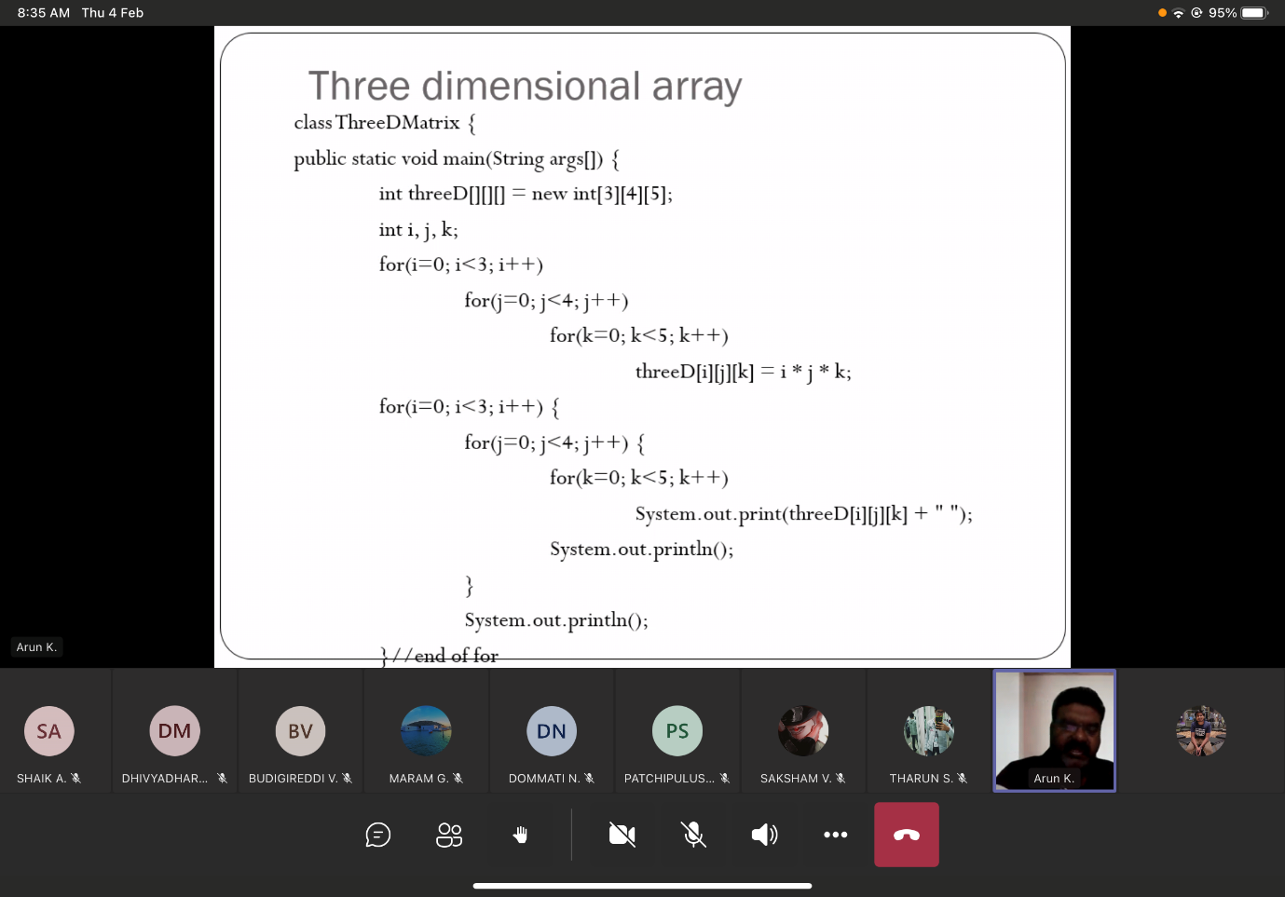

Static

Static 🡪 cannot be changed   
static can be provided for variable,method,class,blocks

Const 🡪 only for declaring variable, const will not available for methods,class,blocks

1. Static block [more priority] will be initialized first.
2. Static method will be initialized.

**static String college = “VIT”** 🡪 All objects will share this common variable.   
No separate memory will be allocated for **college** for each and every objects.

Access control

By default 🡪 public

Private members can be accessed only within the class

Stack

15/2/2021  
1) Inheritance

Box problem

2Super  
Super box problem  
super(ob) 🡪 will call the parent class constructor, then only the child class constructor.

1. Multi-level inheritance

multi-level box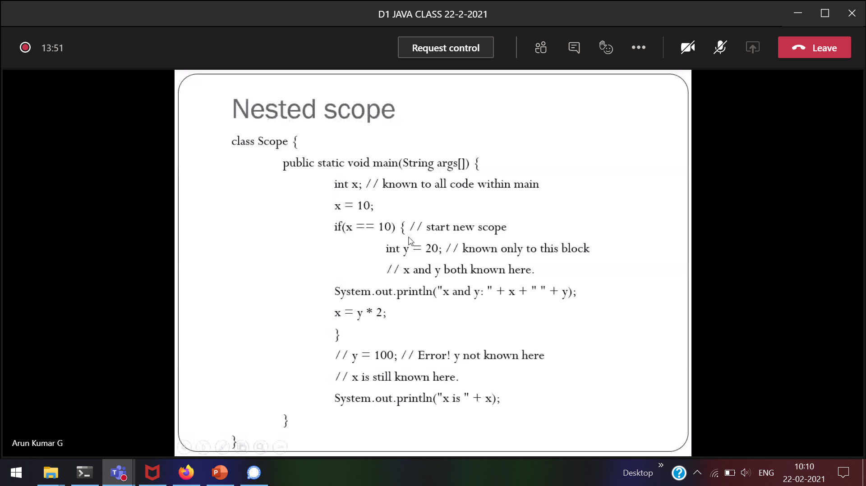



y is declared within the if-loop, so outside if loop 🡪 y will give error  
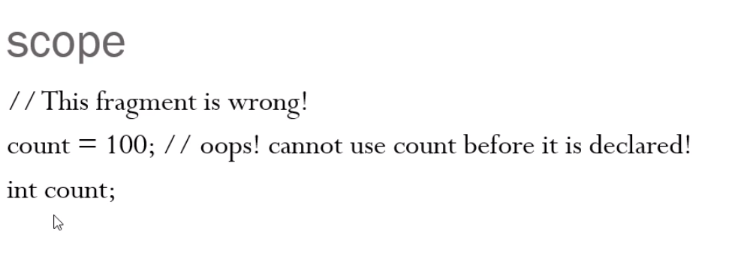  
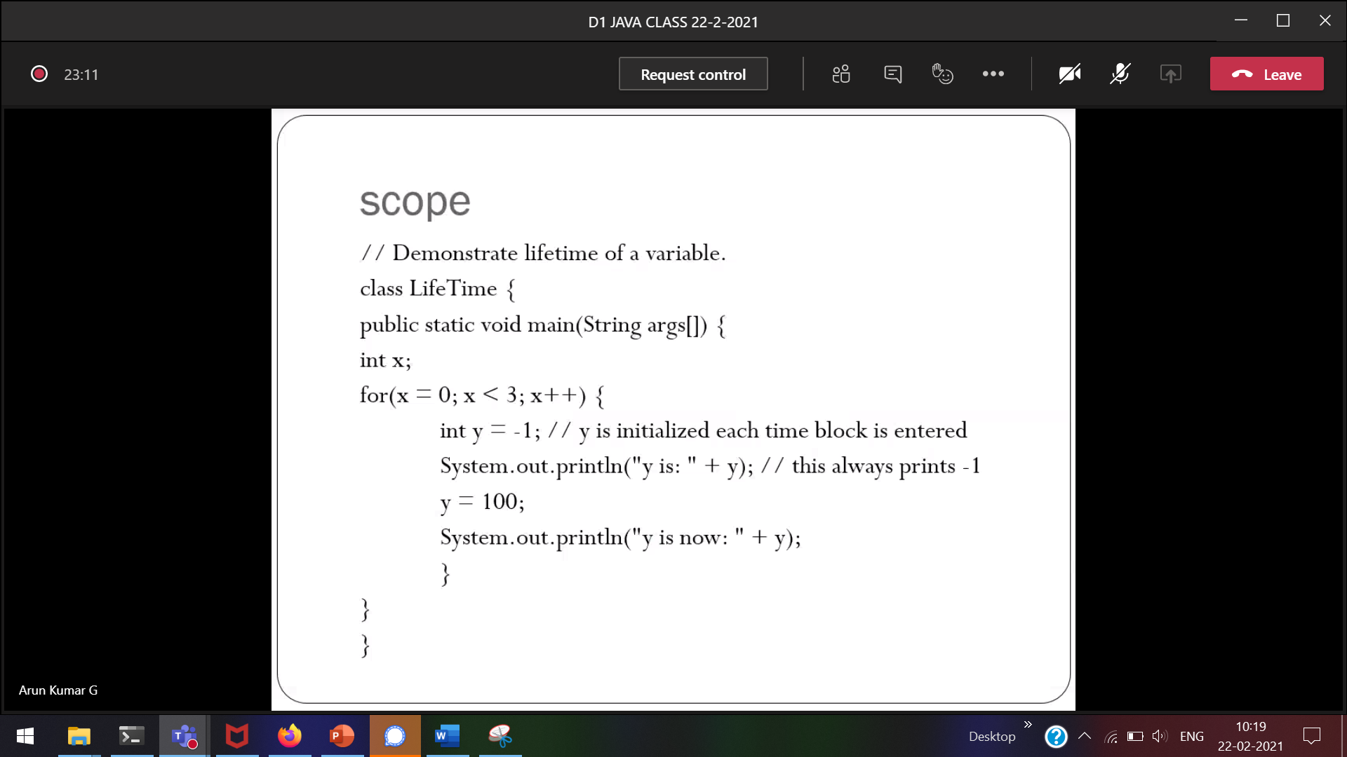

y is declared only within the loop.   
Life of y is within the for-loop.

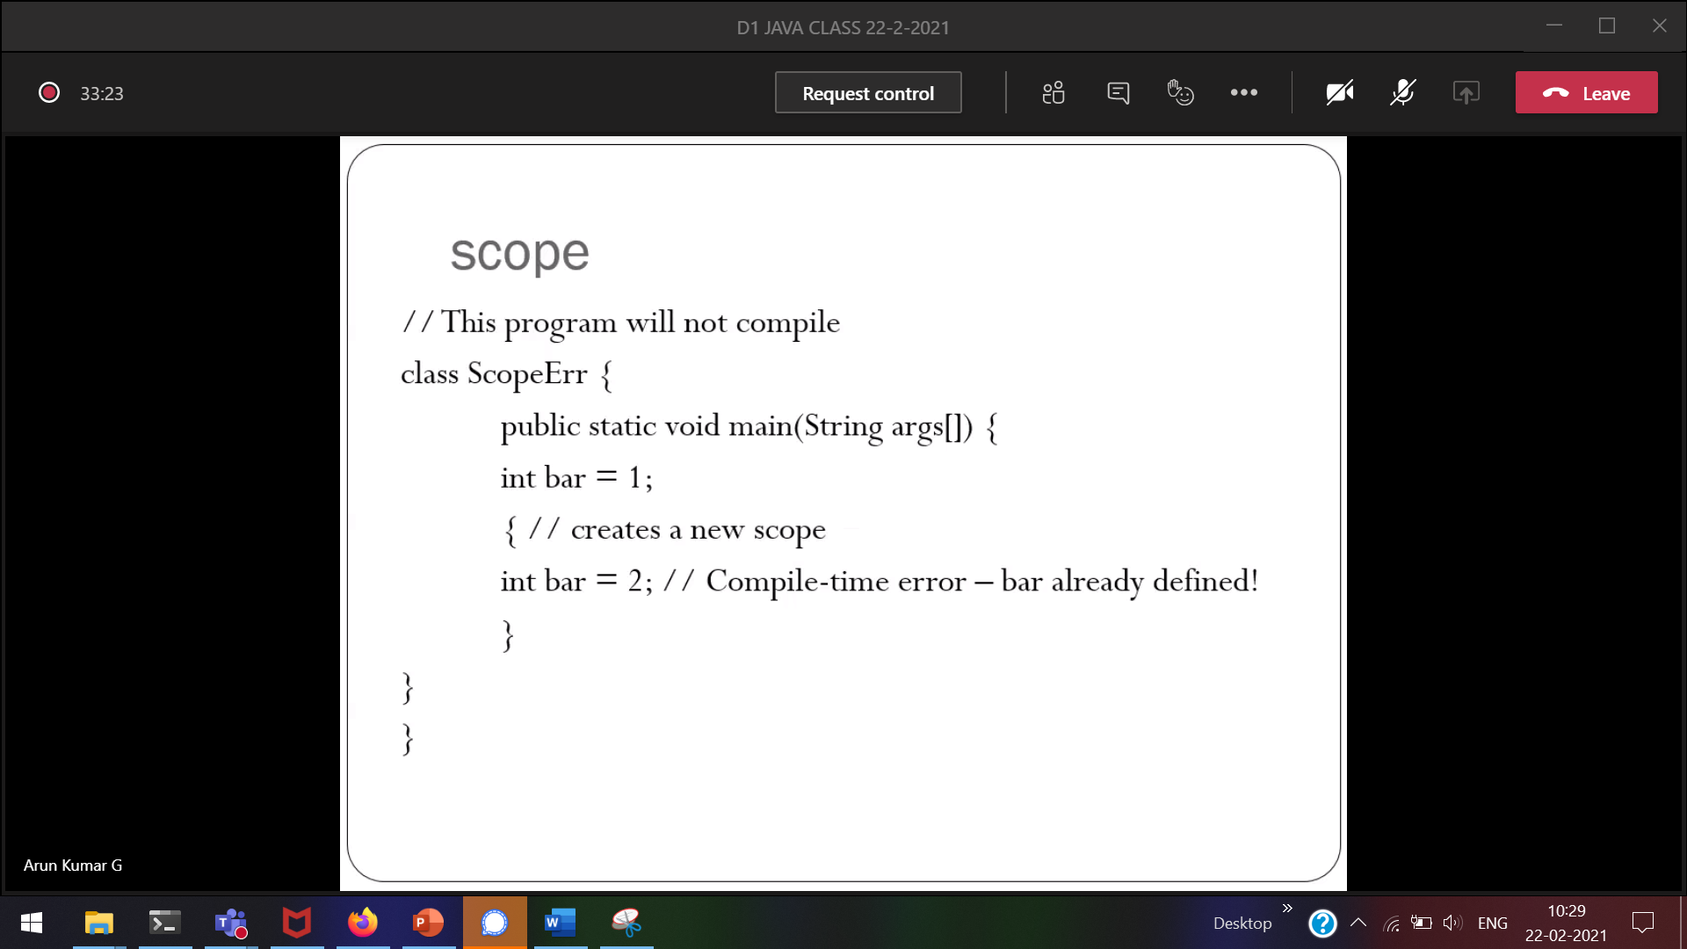

Same variable name within a function 🡪 Not allowed

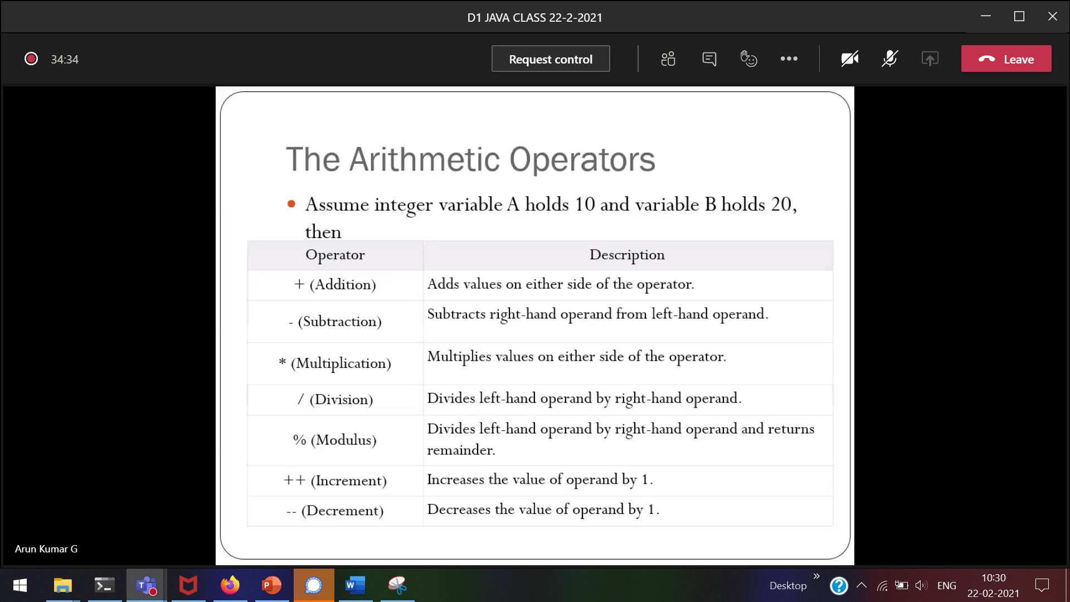  
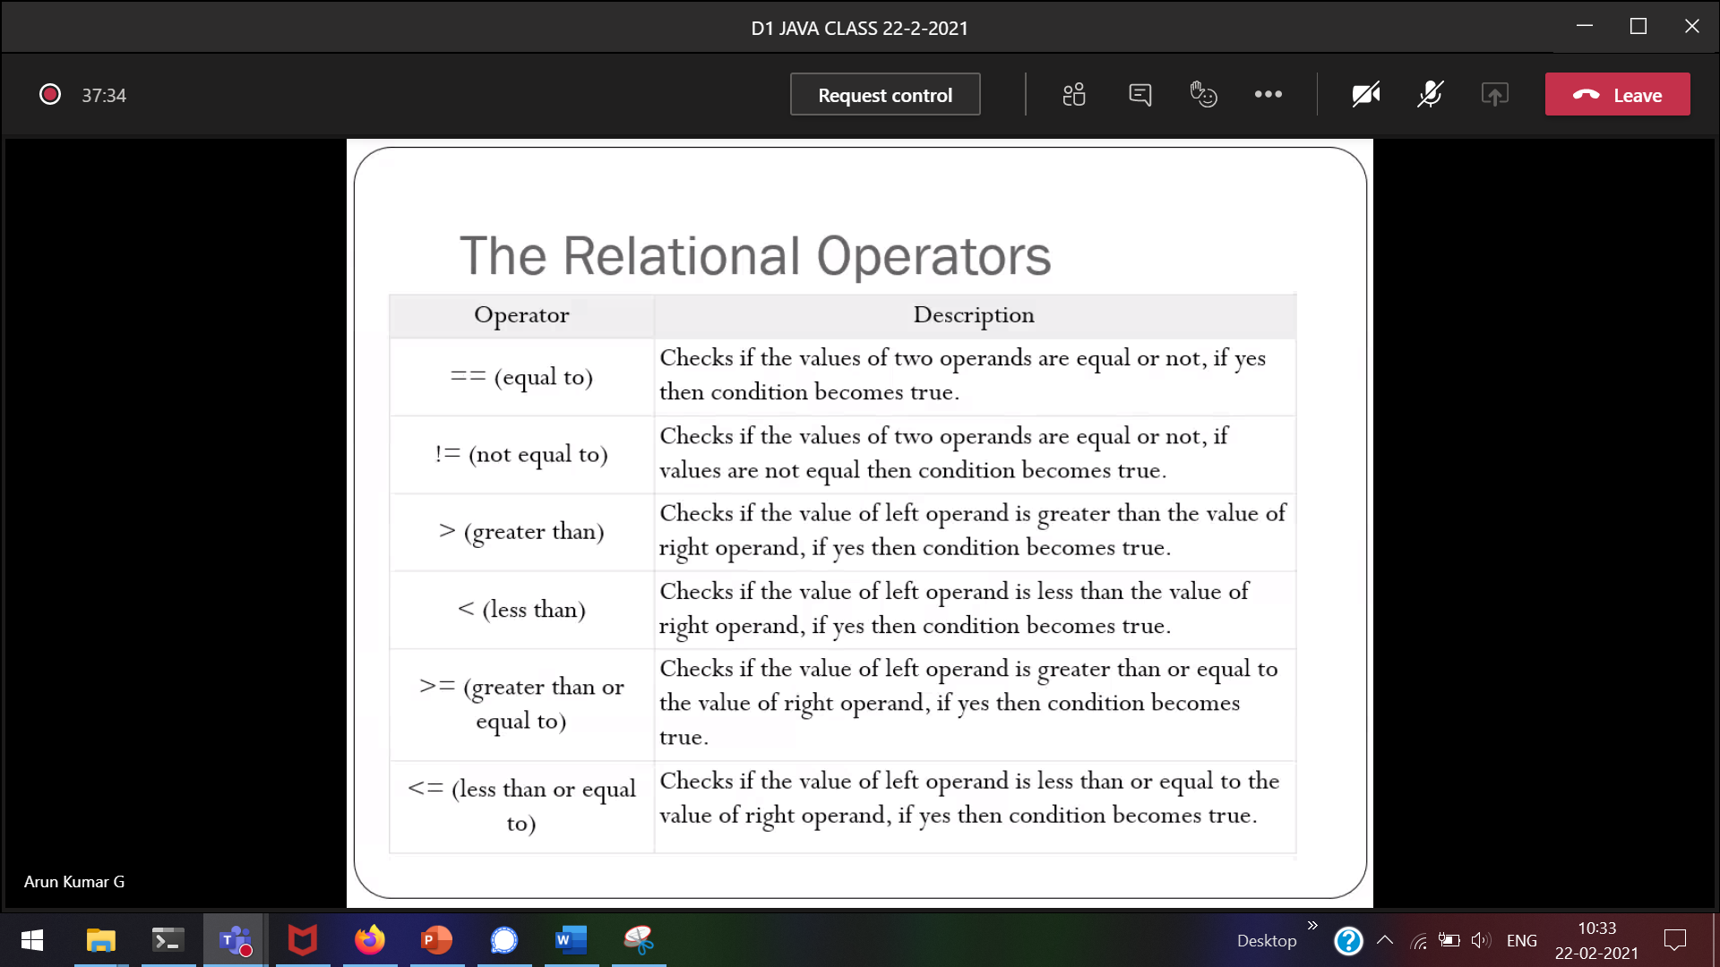

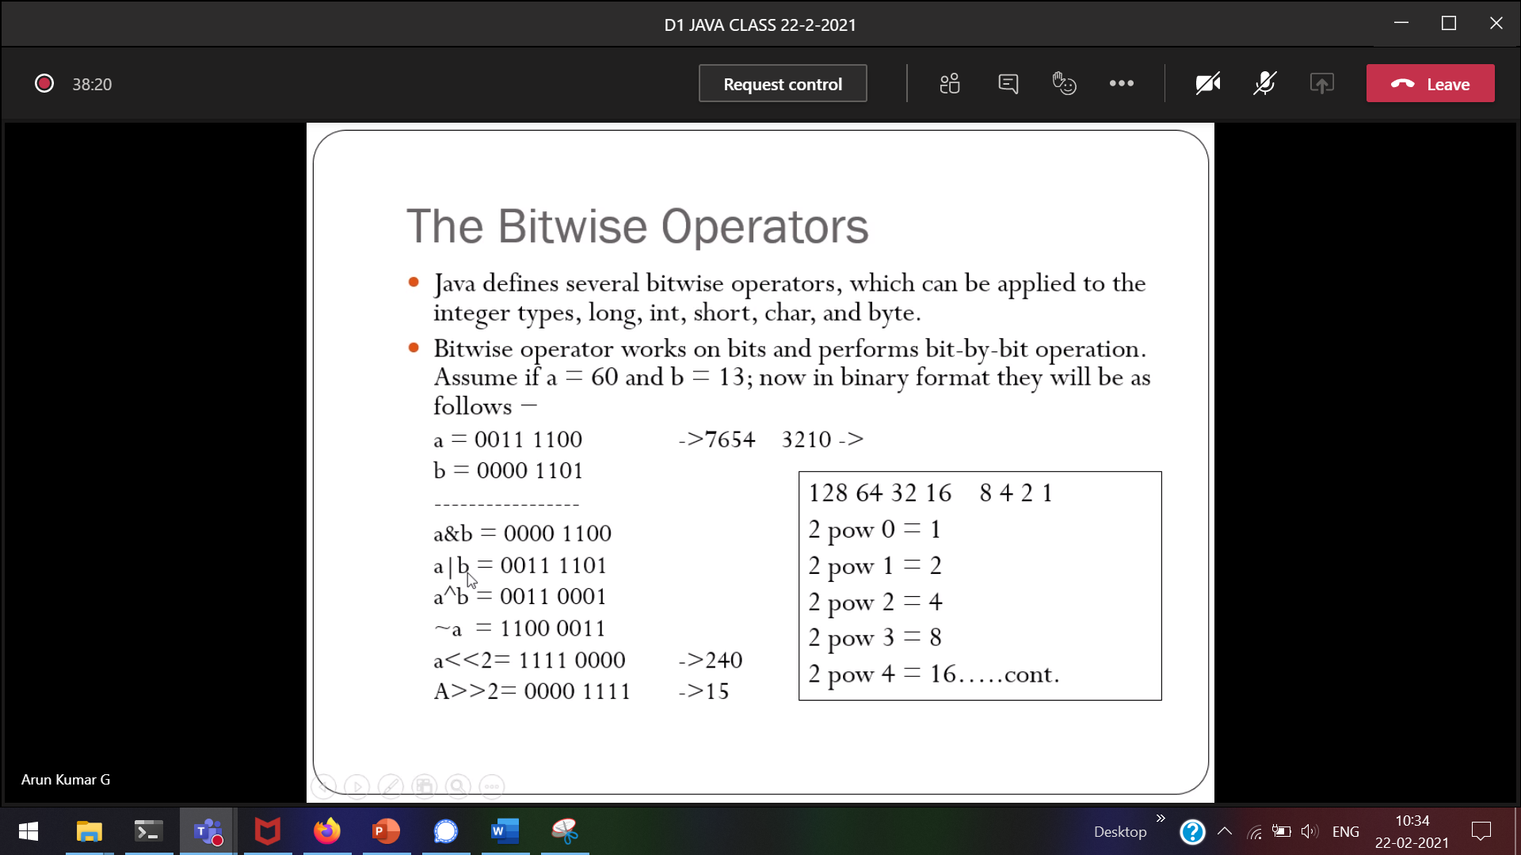



Left shift right shift

Left shift 🡪 a<<2 (a*4) 4 because 2^2=4  
Right shift 🡪 a>>2 (a/4) 4 because 2^2=4

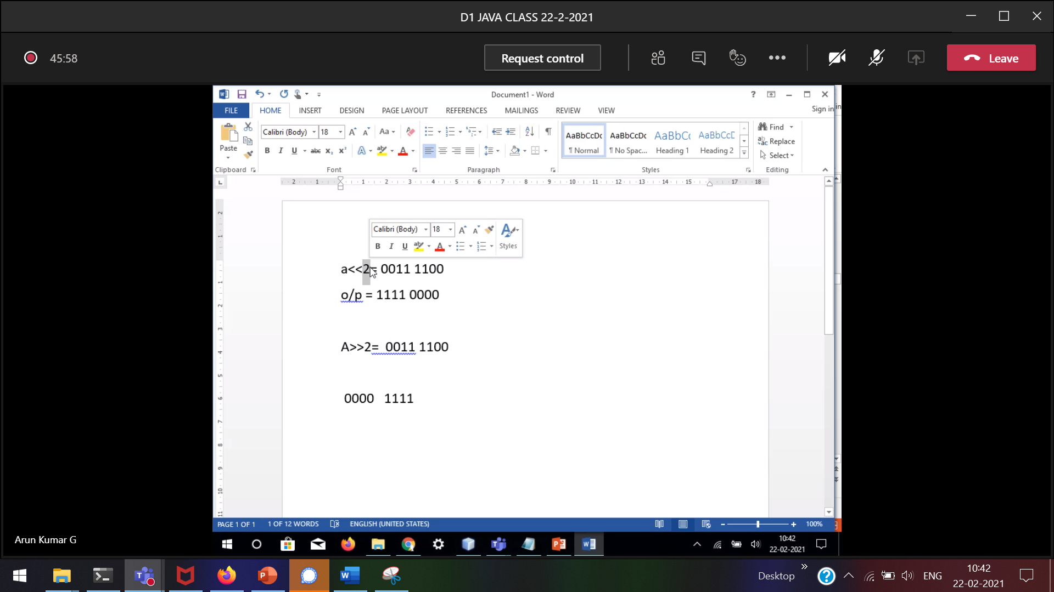

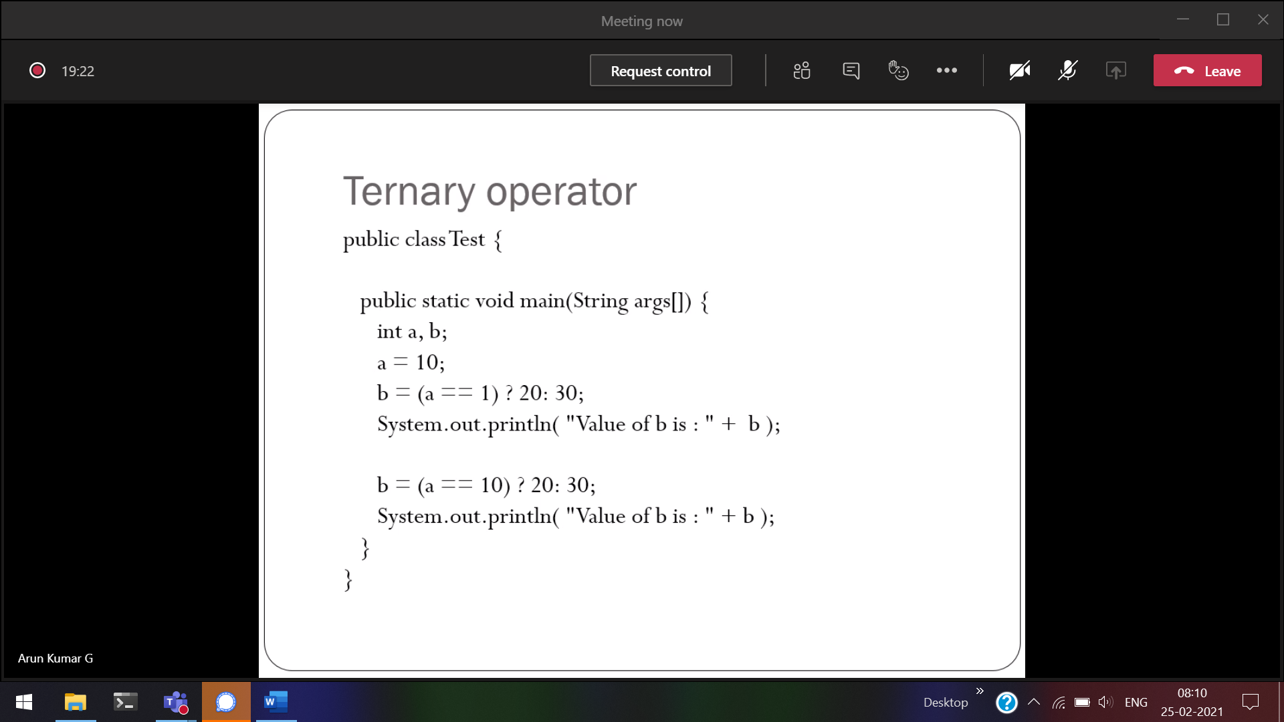

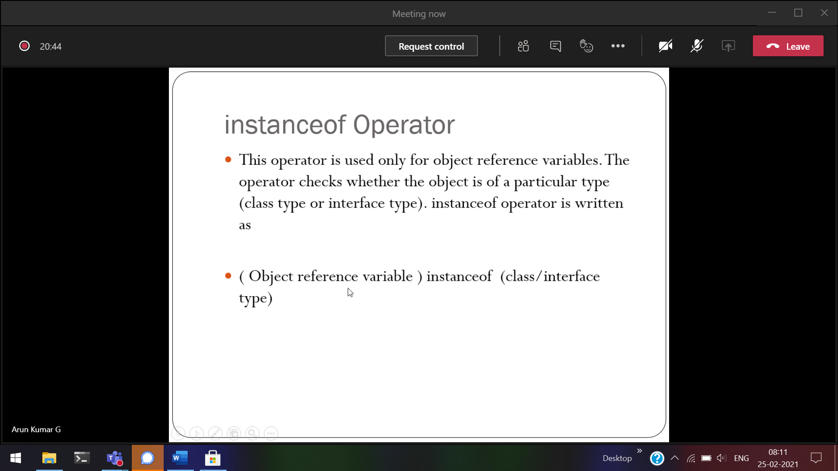

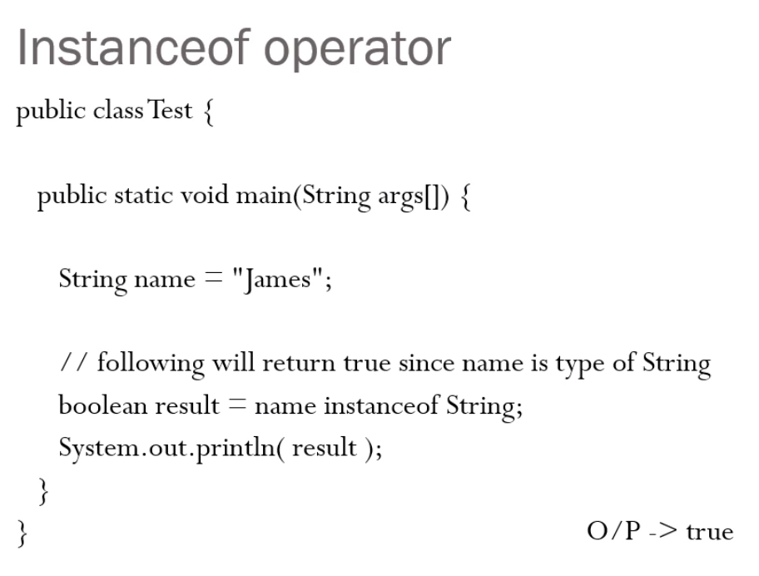  
which object belongs to which class we can use instanceof String.



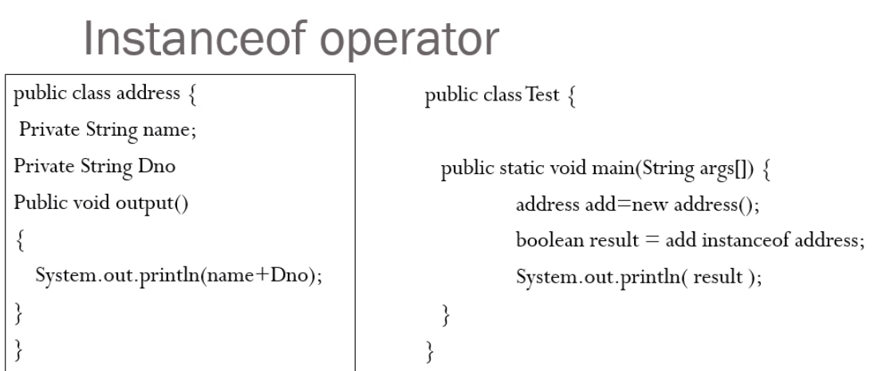  
This will be used during large programs



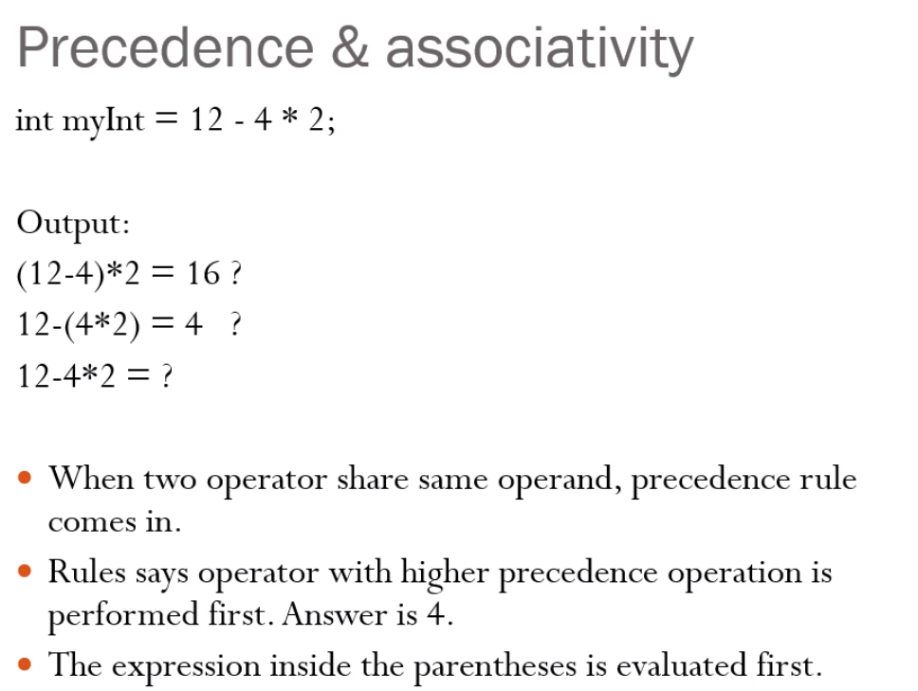



How the system know the precedence

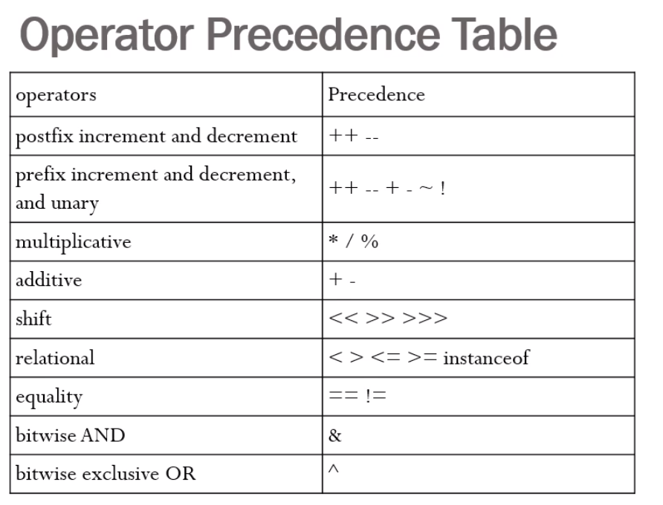

When the precedence is same, associativity will come into picture.

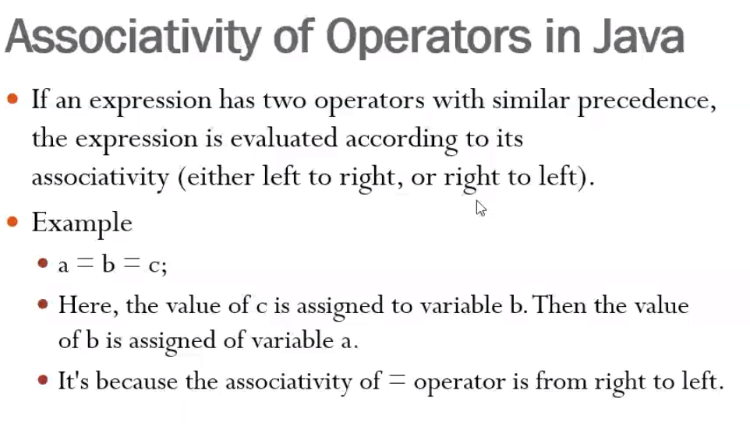

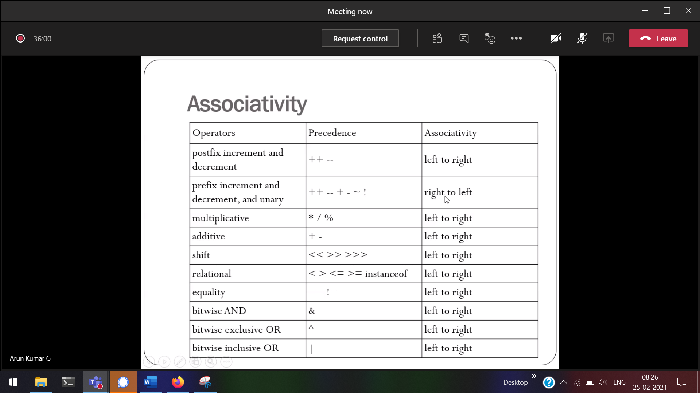

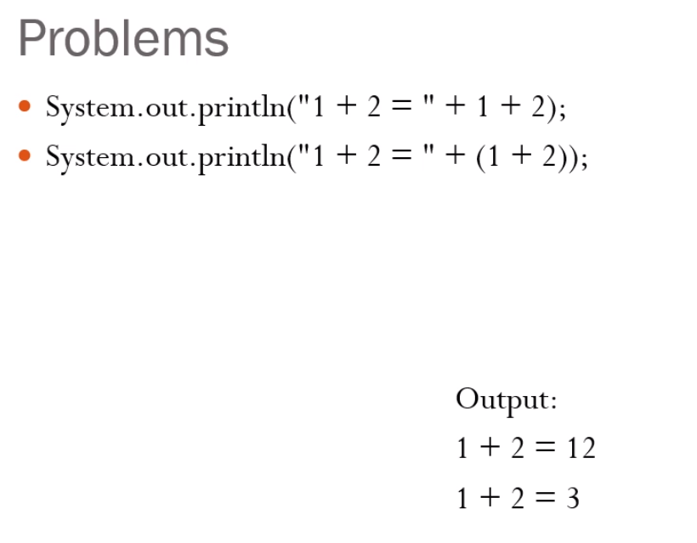



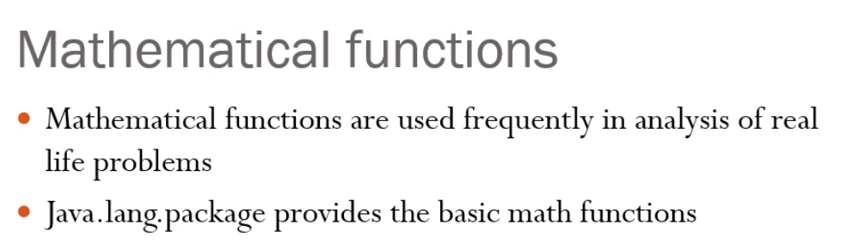  
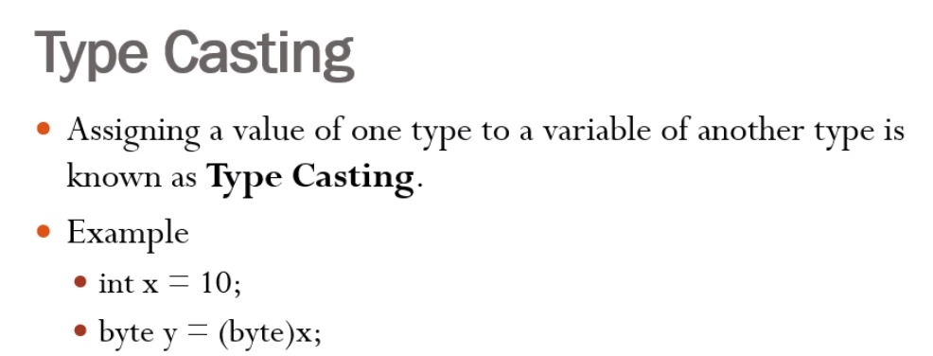



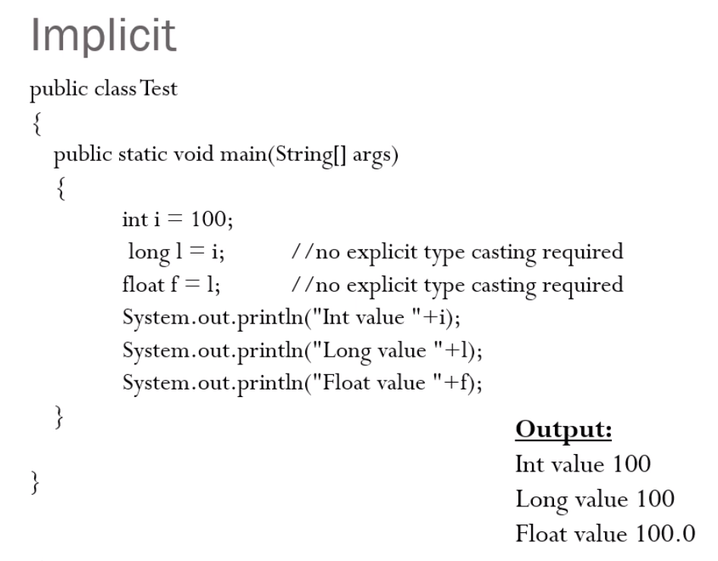  
Smaller to larger



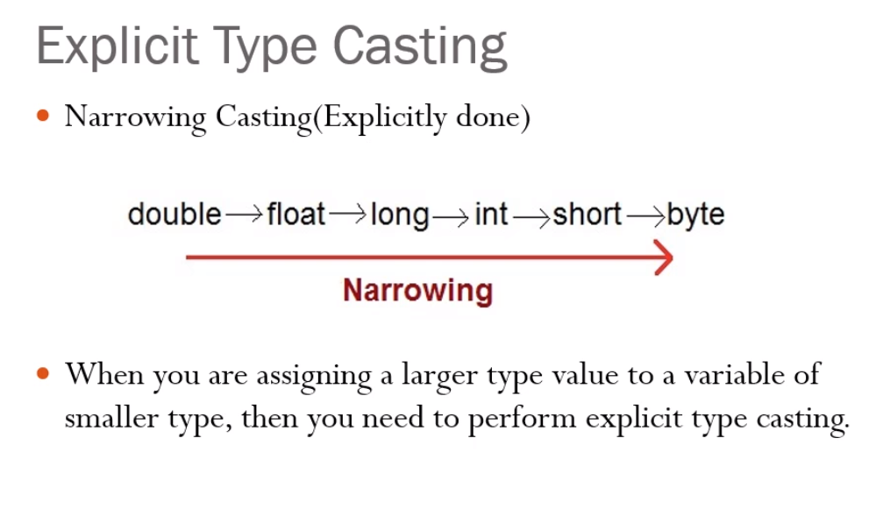  
larger to smaller

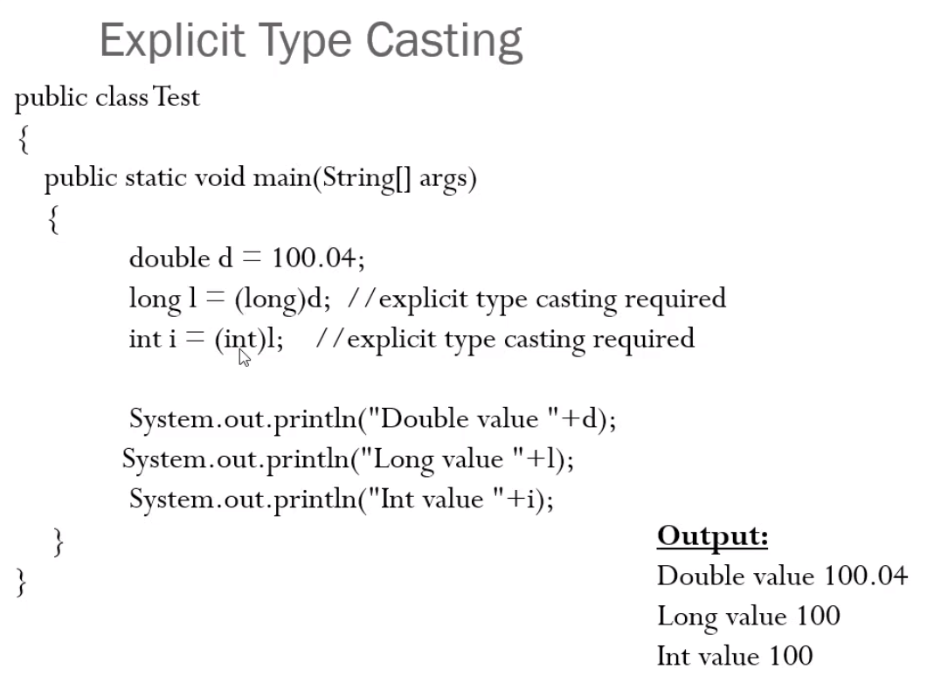

double>long>int

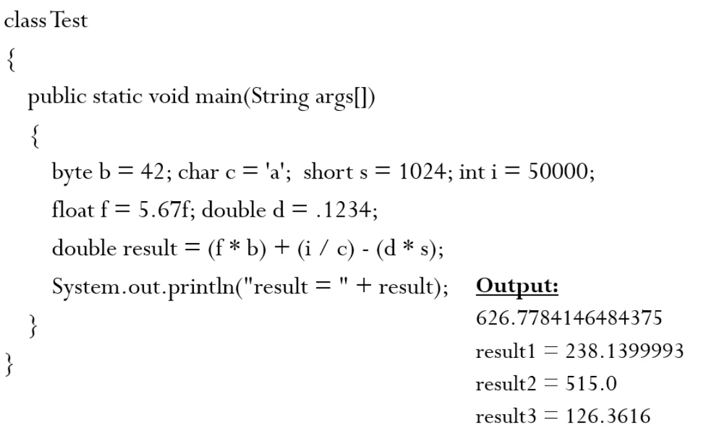  
Since double will be larger, the answer will be also in double.



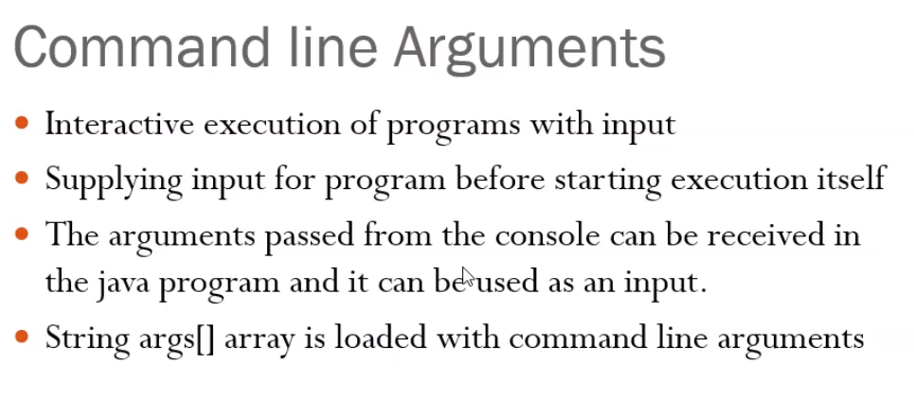

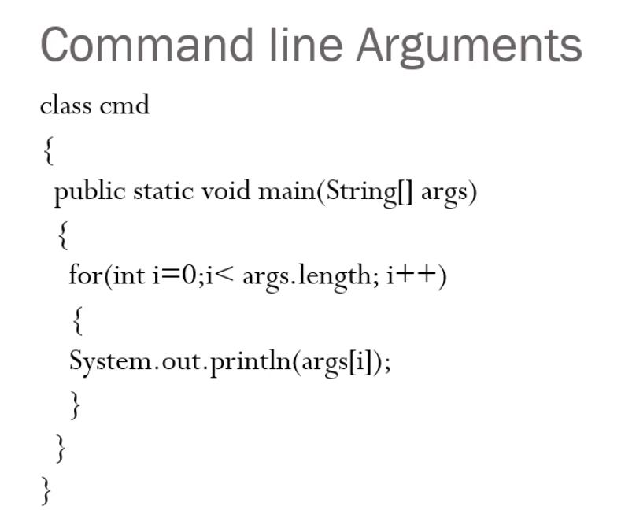



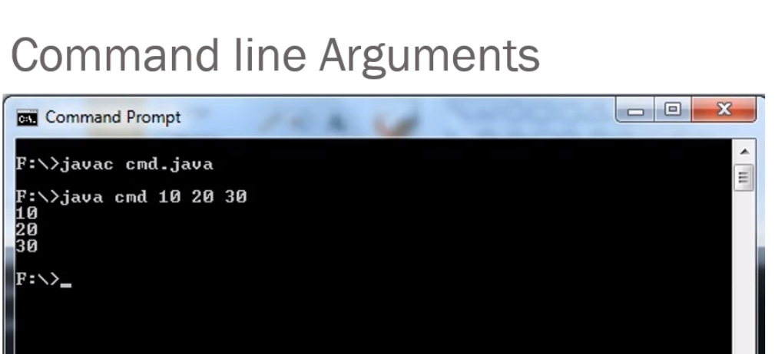

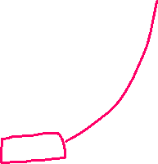

Cannot create objects for abstract class.

figref = r;

figref is not an object, it is a reference to an abstract class.

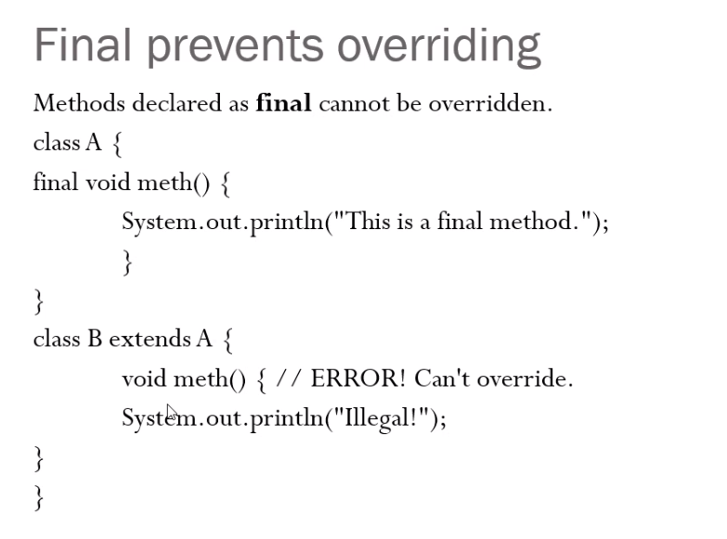



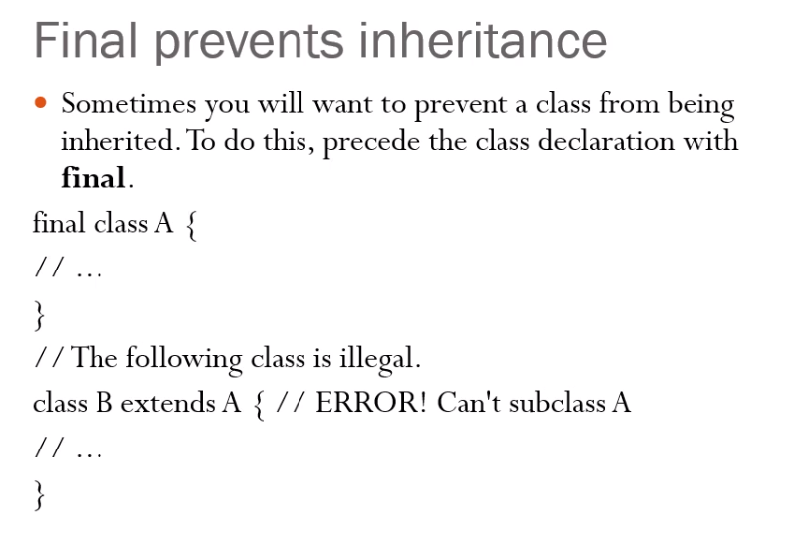

final 🡪 unique

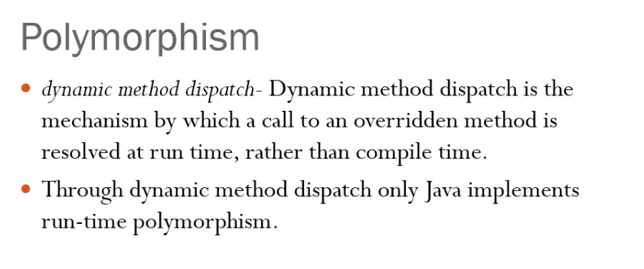

<https://www.geeksforgeeks.org/polymorphism-in-c/>

dynamic method dispatch (JAVA) 🡪 virtual functions[C]

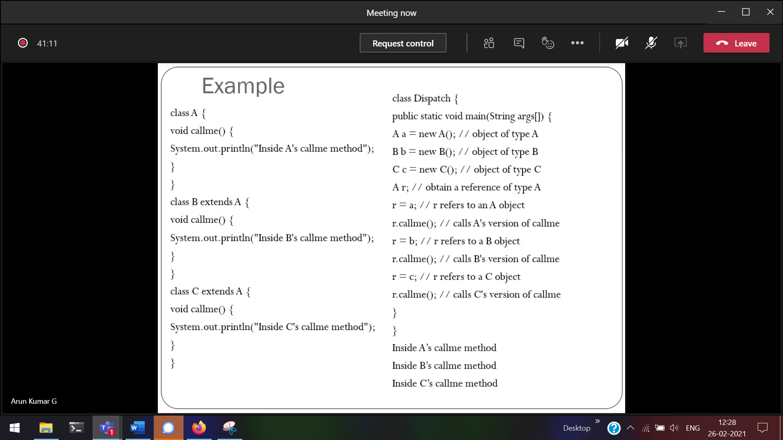

Taking the decision at the run-time 🡪 polymorphism

Child class method is supressing/over-riding/dominating the parent class method.

B’s call me is over-riding A’s call me.  
C’s call me is over-riding B’s call me and A’s call me.

Over-riding 🡪

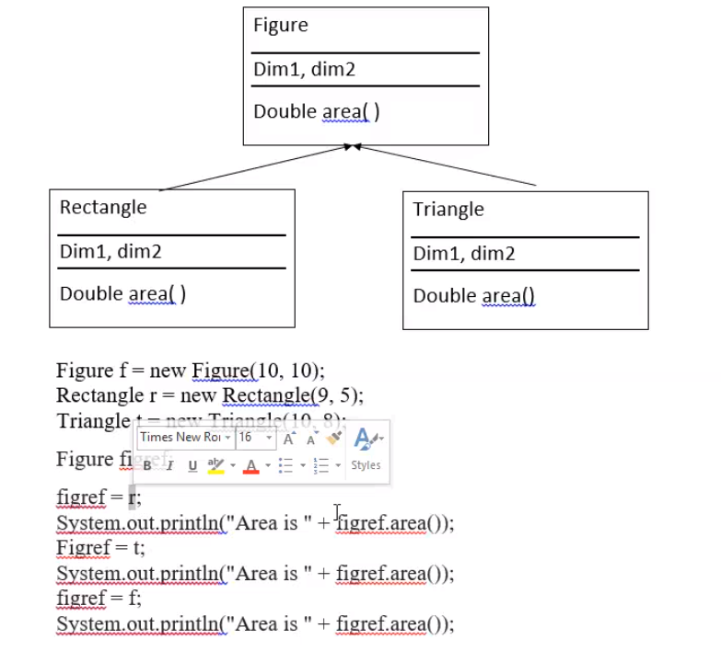



figref 🡪can access the child class properties.

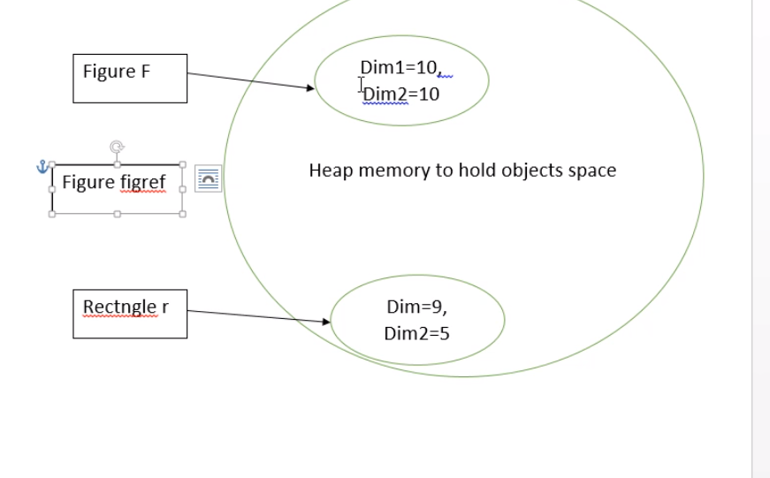



figref 🡪 only a reference

In C, Figure figref 🡪 figref (dim1 , dim2 ) = (value1, value2)  
But in Java, Figure figref. figref is only a reference object

Packages and Interfaces

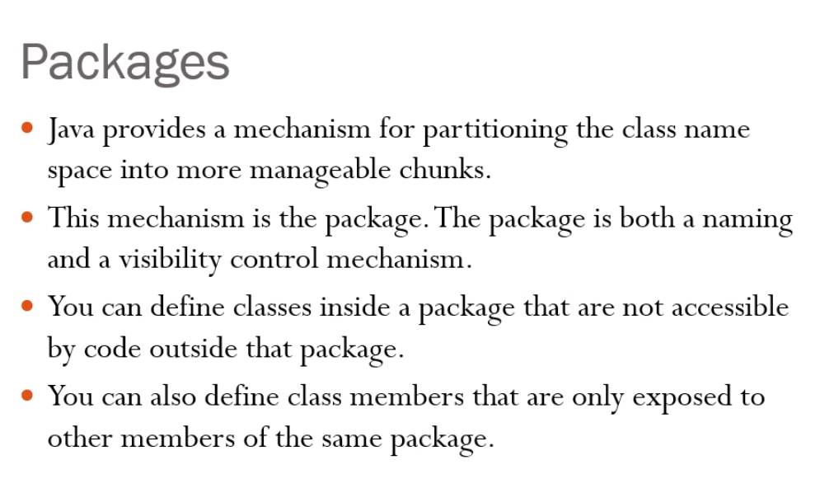

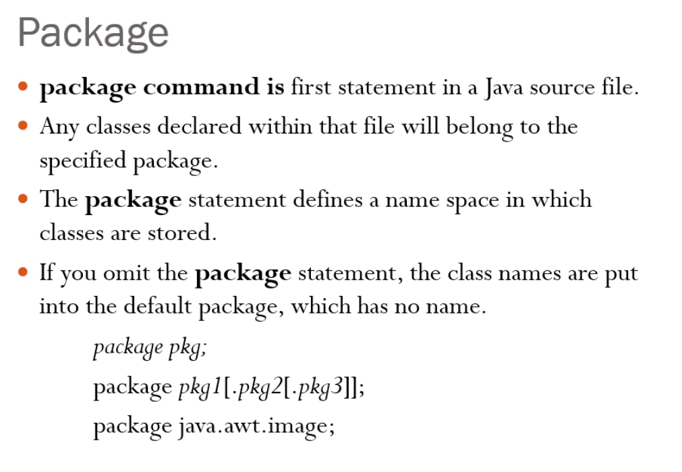

package 🡪MyPack  
MyPack 🡪 AccountBalance

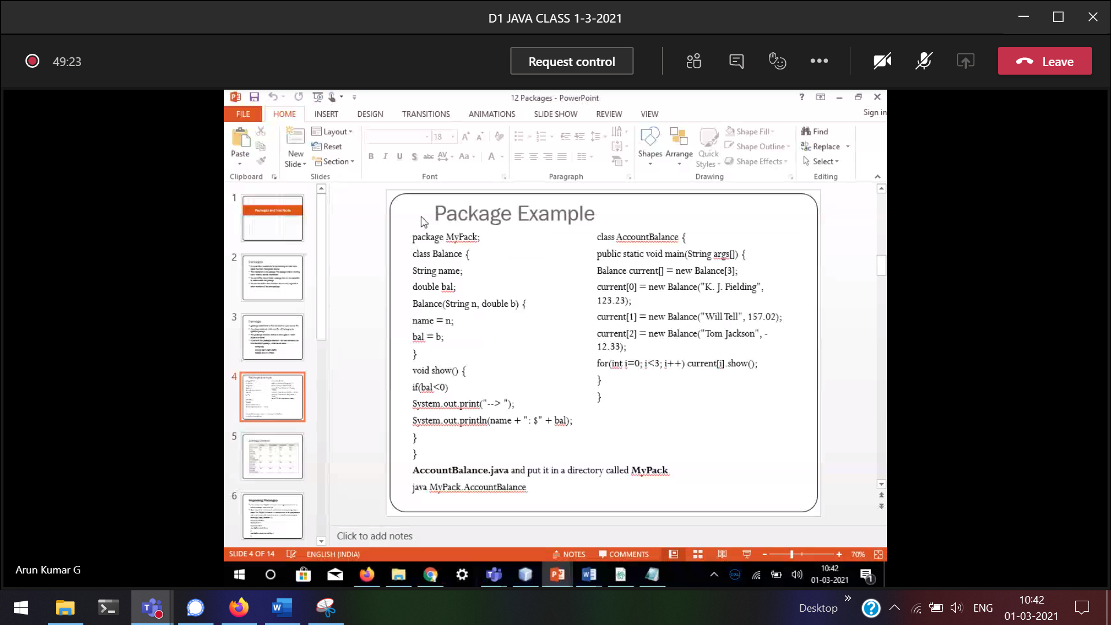

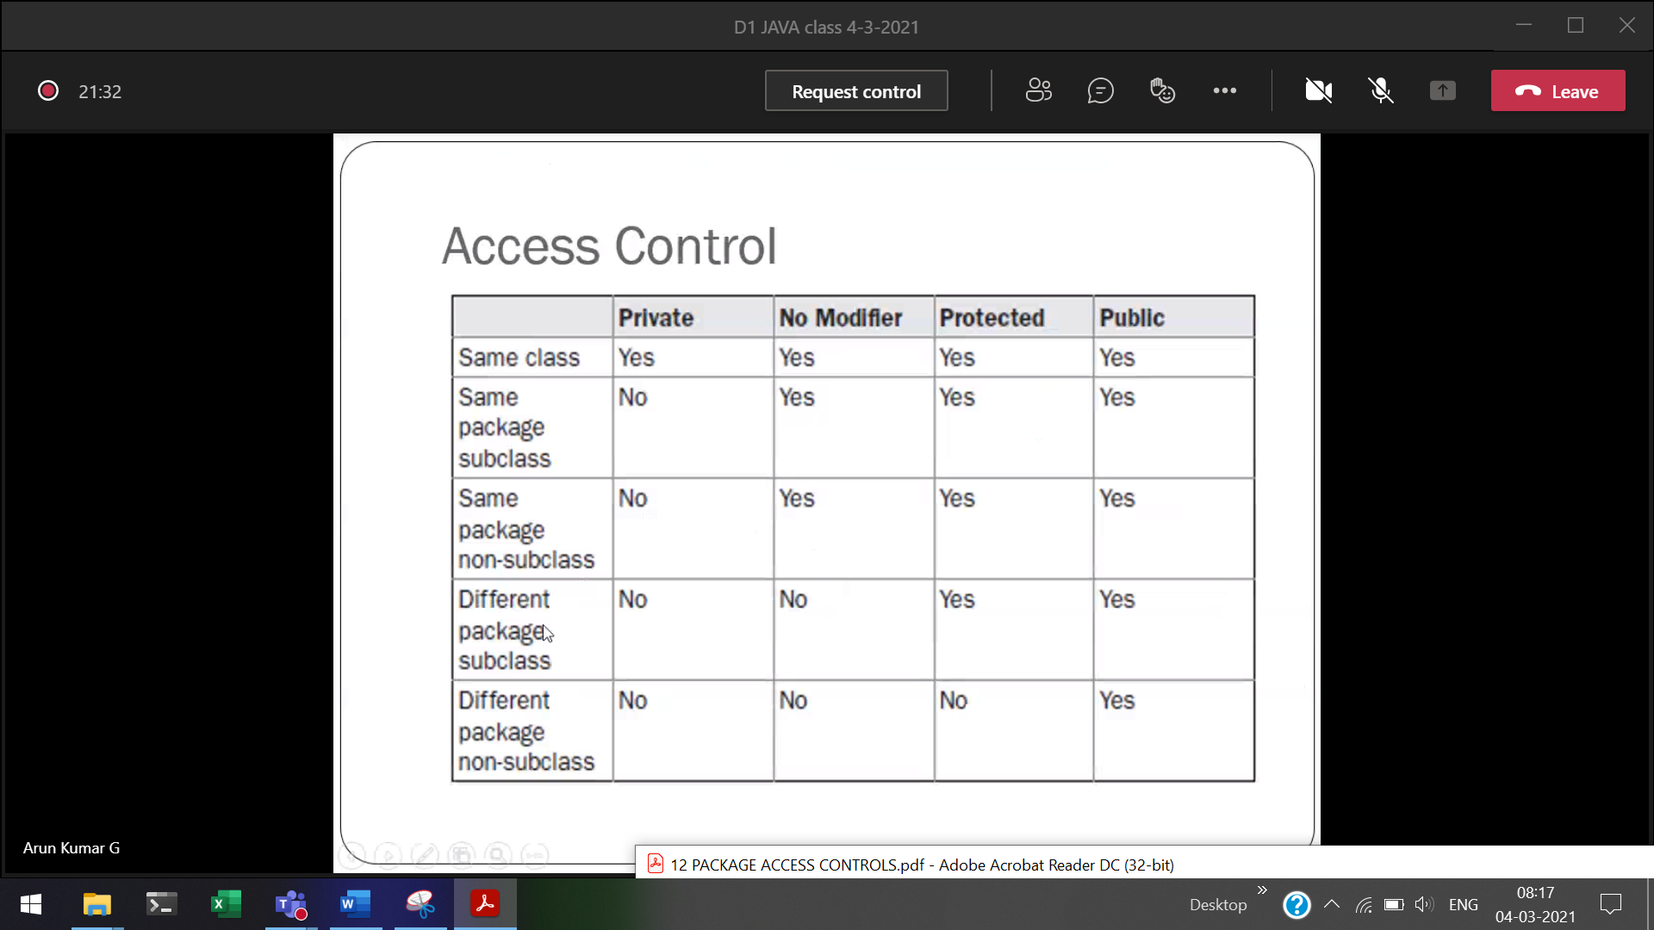

In JAVA protected can be accessed without inheritance also

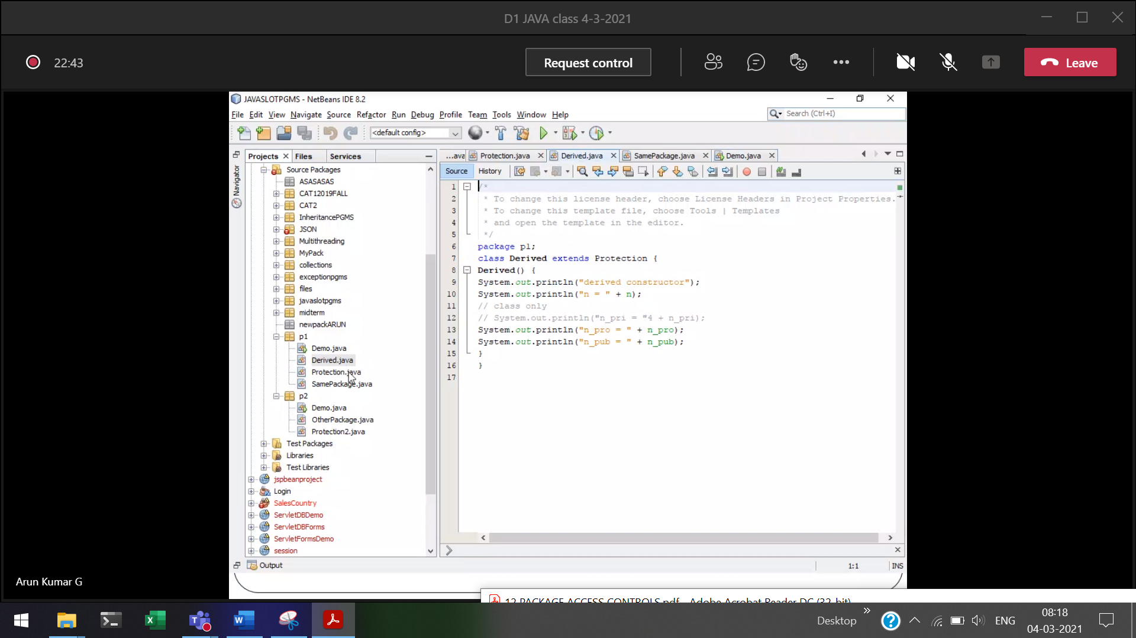



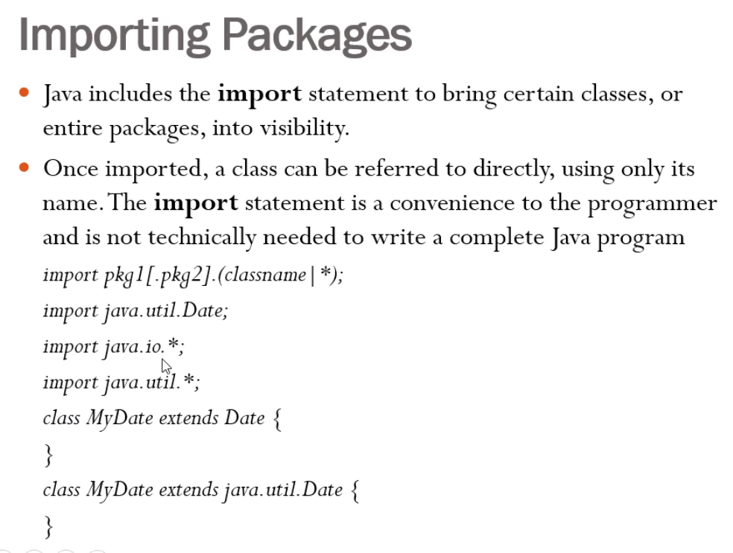

.* 🡪 will download all the packages under that particular library

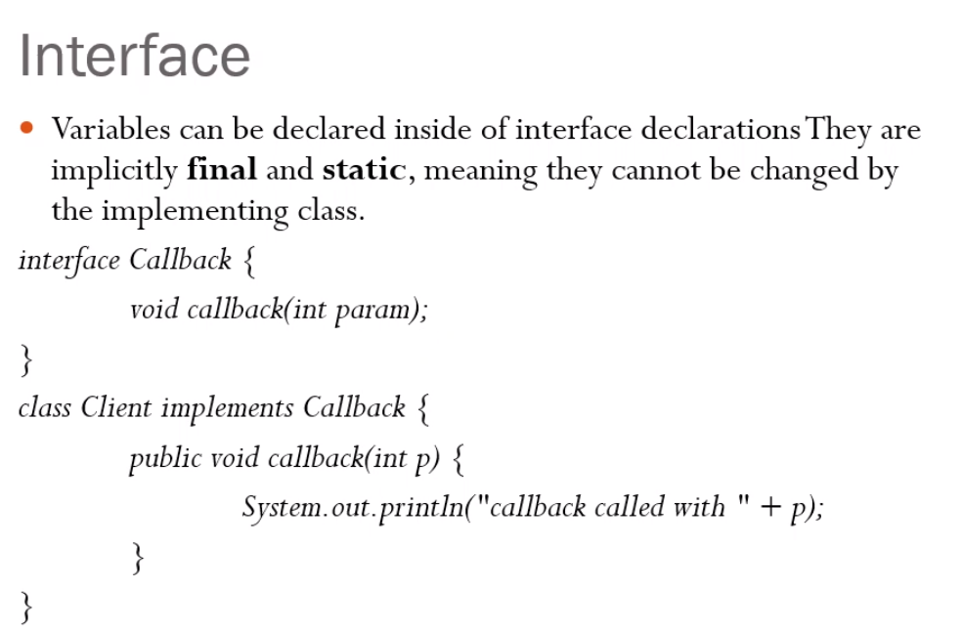



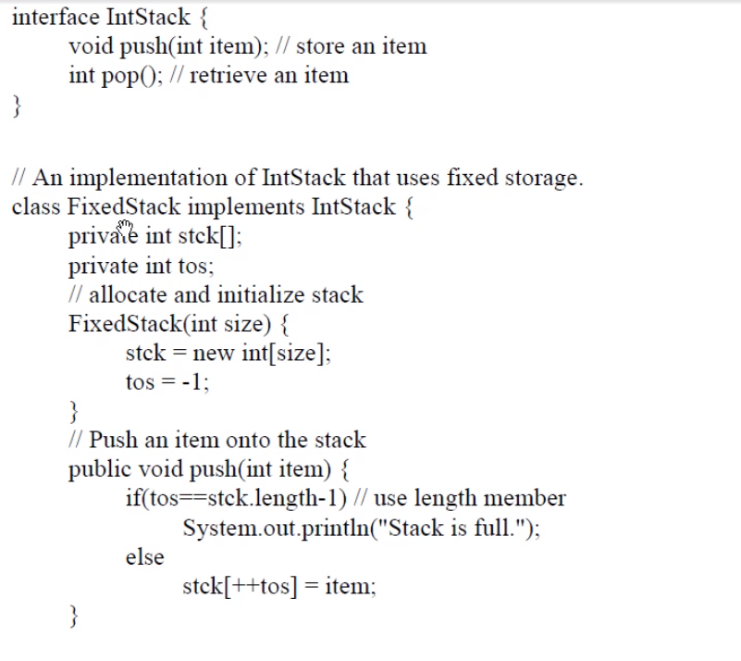  
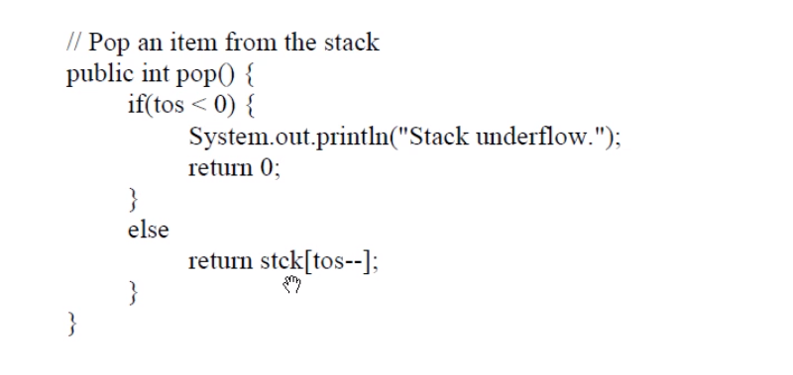



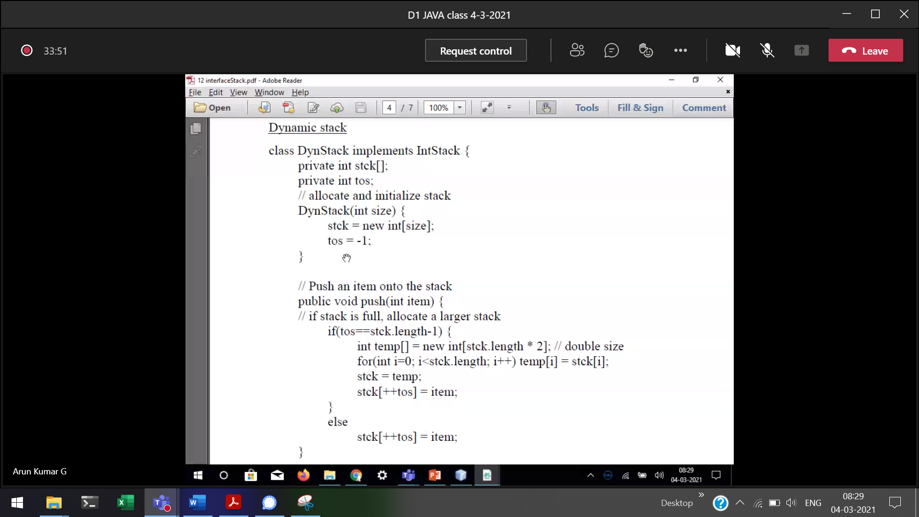



Size of the array is increasing twice, if there is no element.

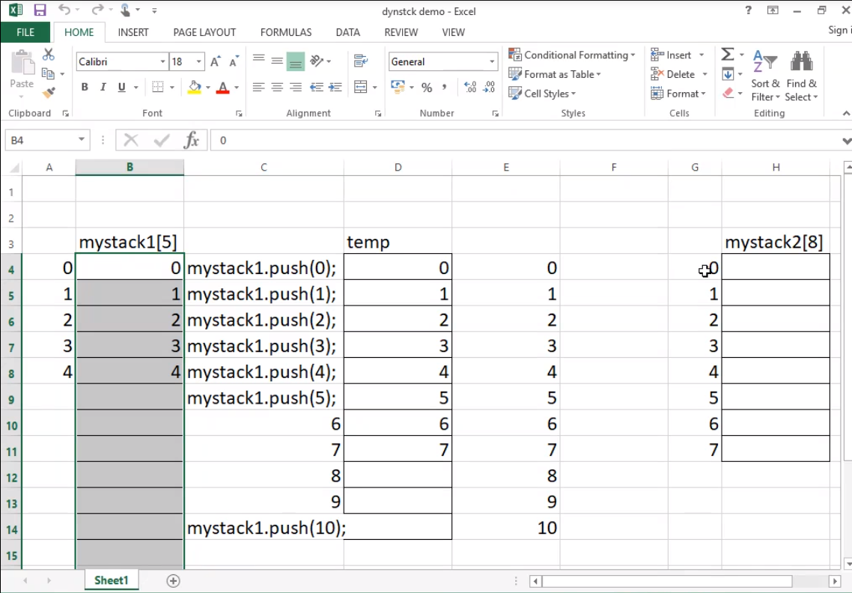

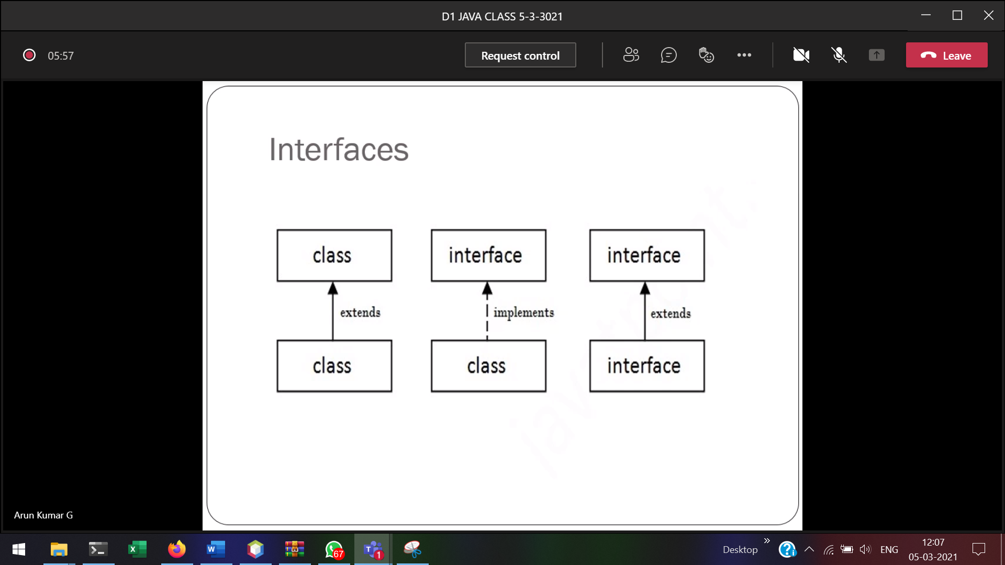

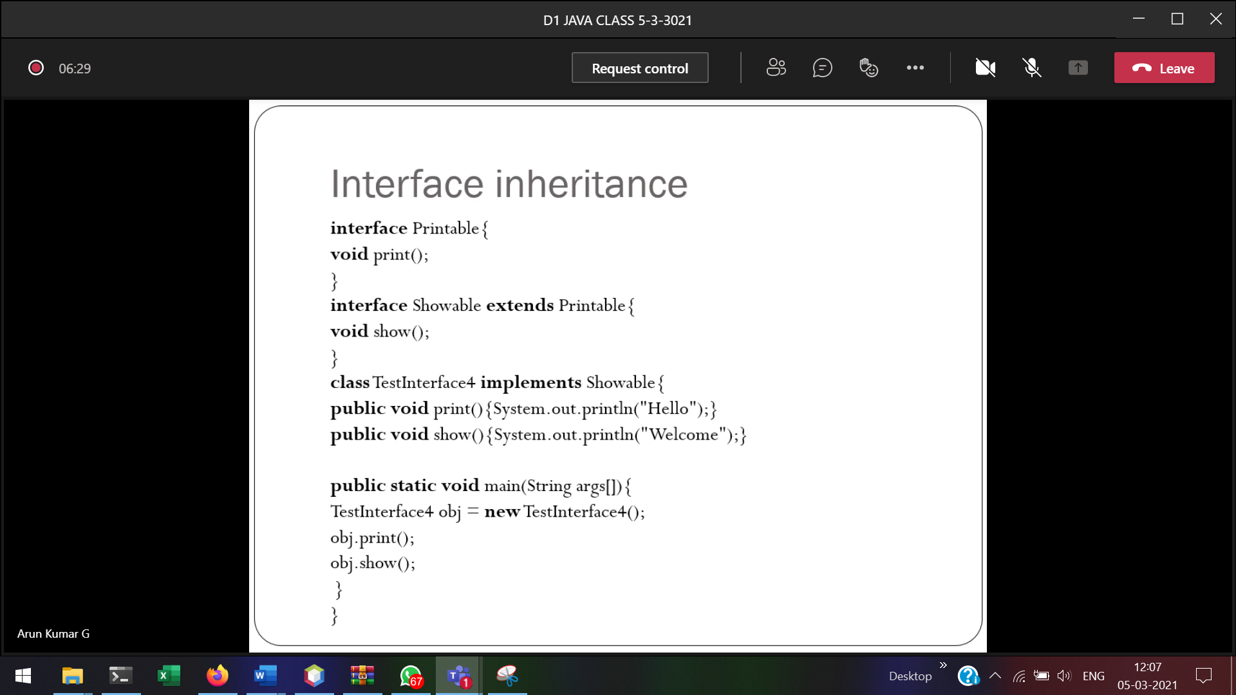



Definition of print() and show() is necessary.  
Object will be created only for class and Not for interfaces.

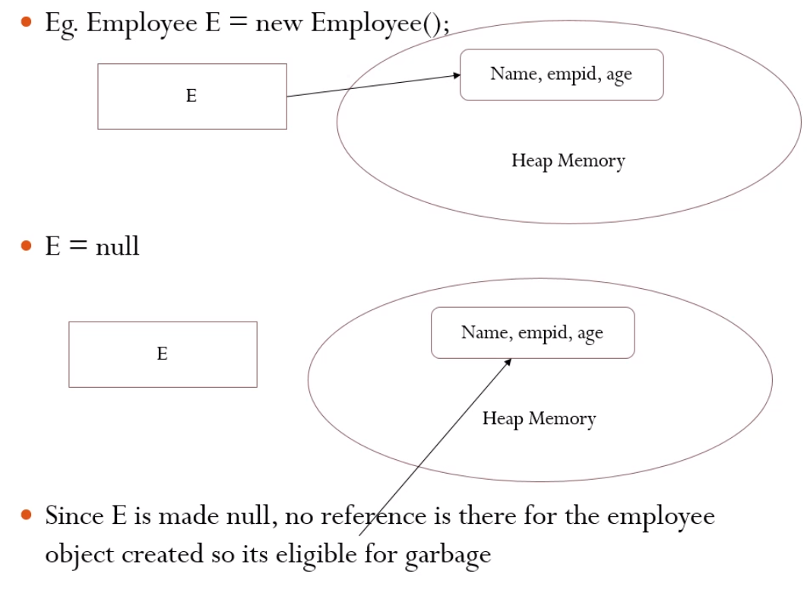



JVM will delete the garbage

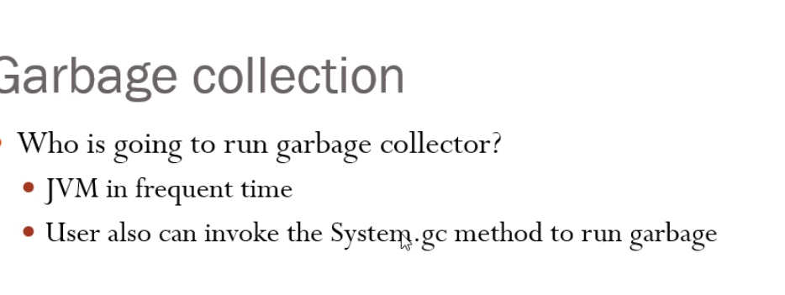

I want to know when the garbage’s are cleared

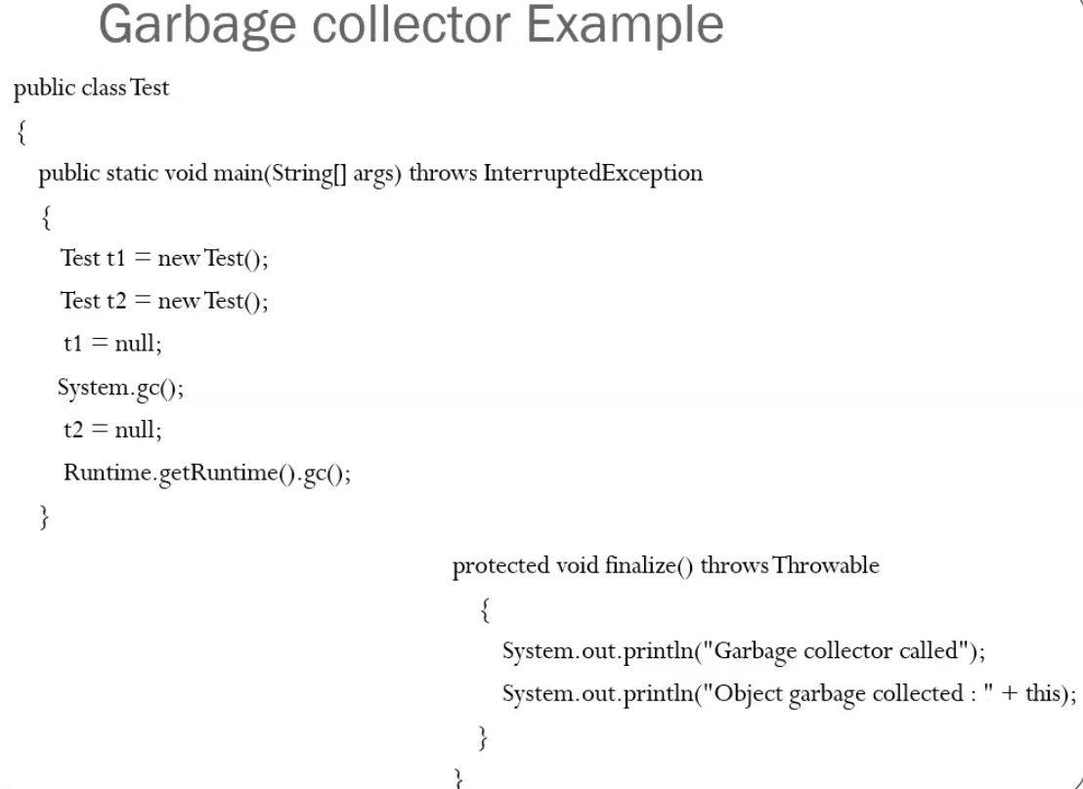

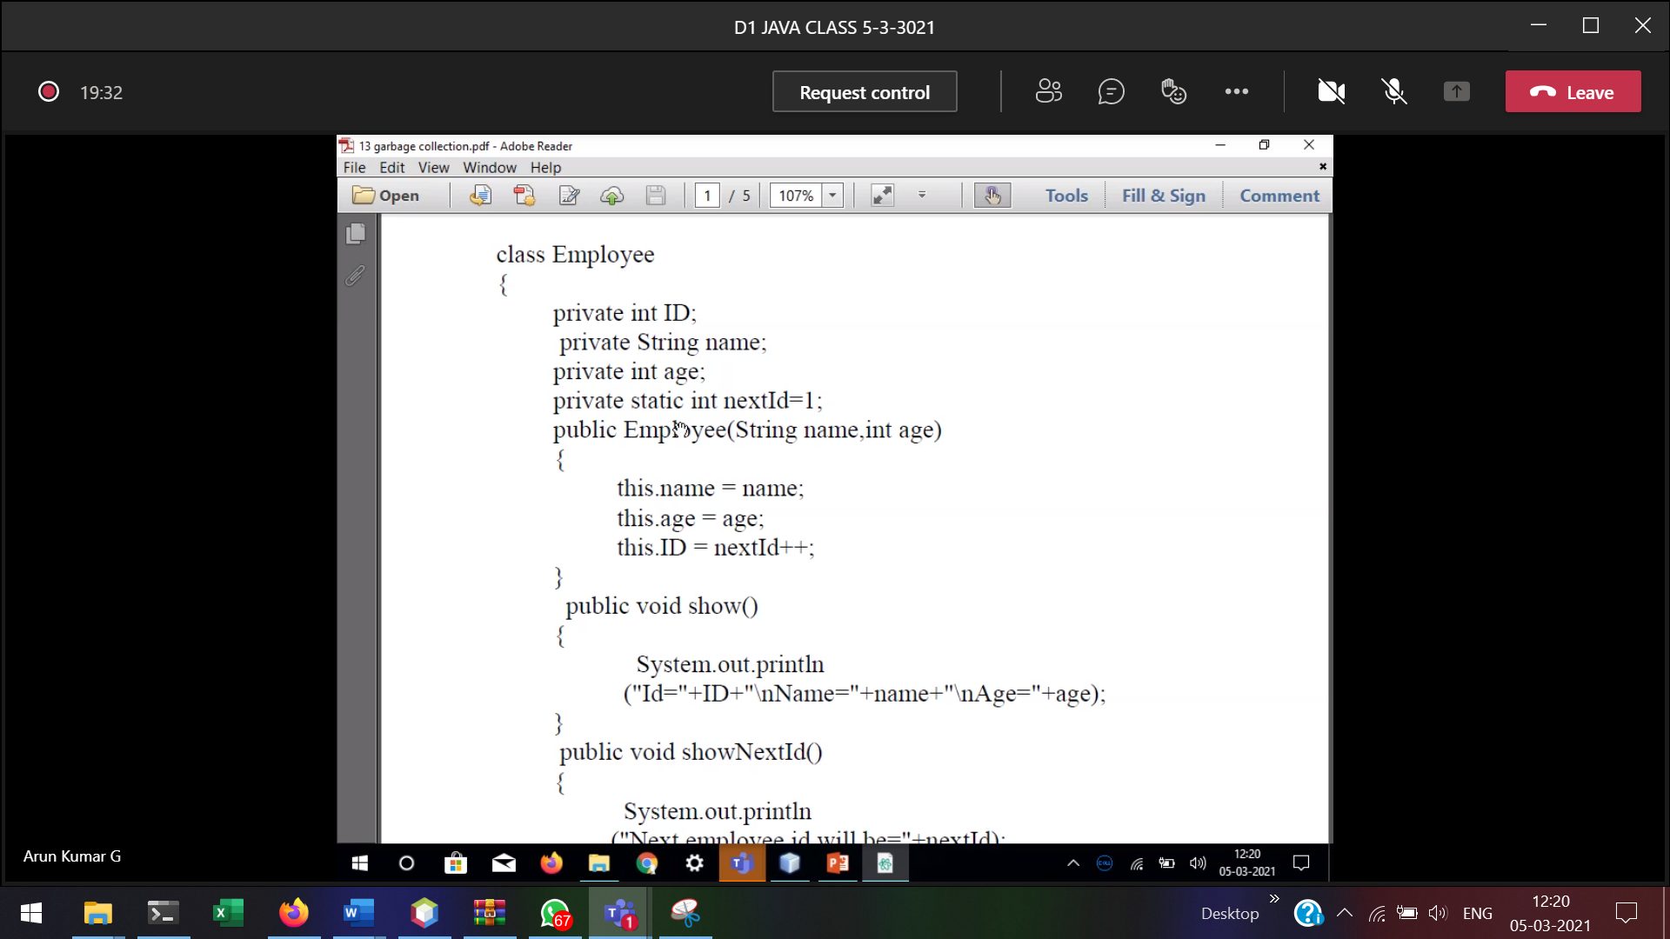

nextId 🡪 will keep a count of how many objects are created.

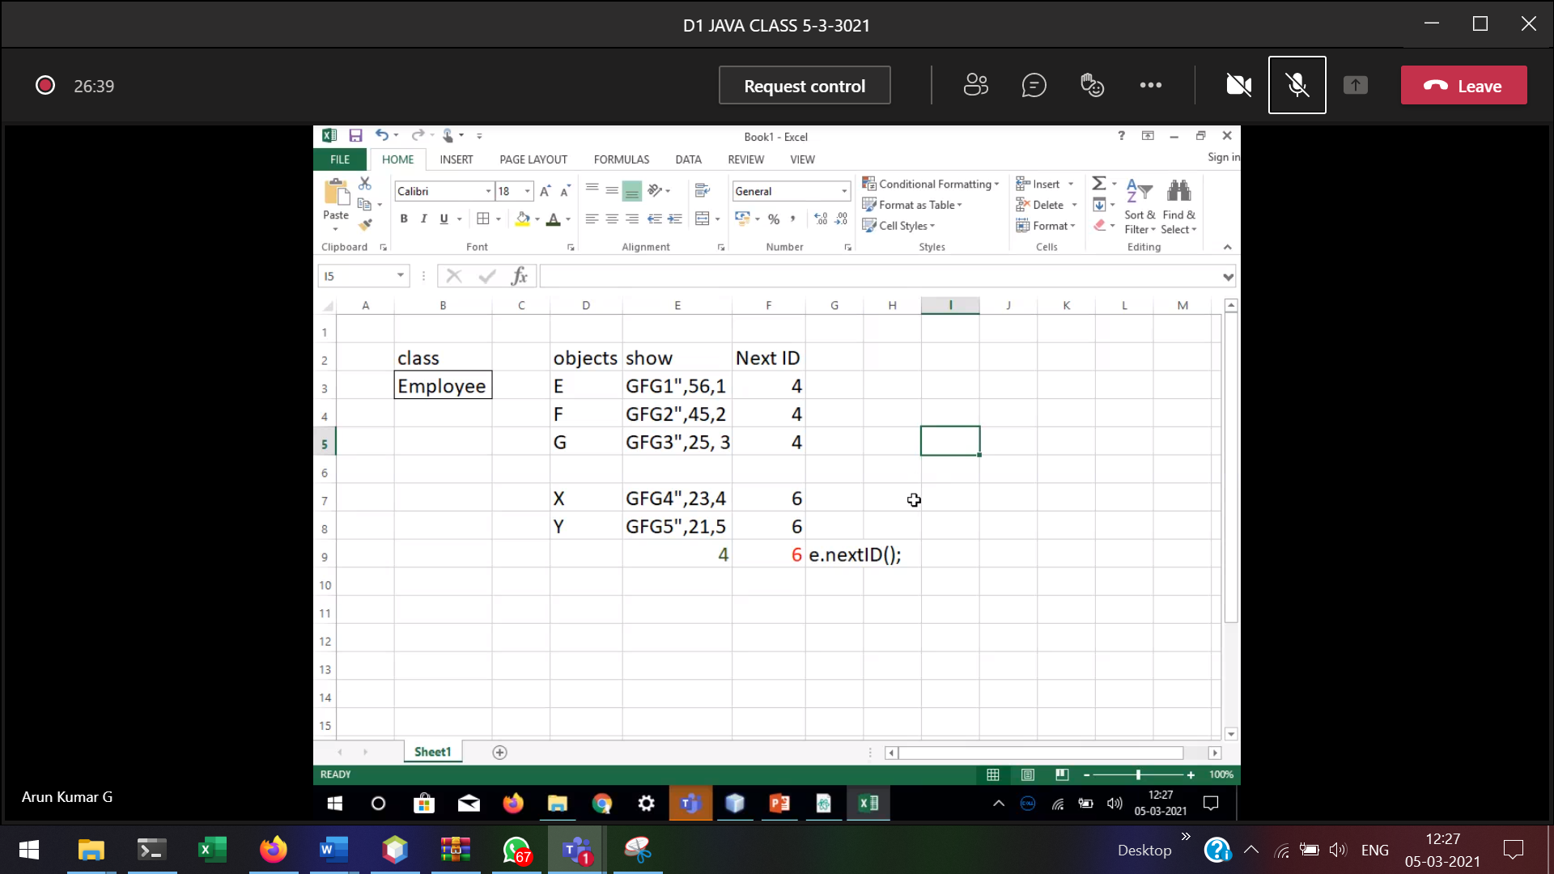

Object created 🡪 nextID++  
Object destroyed 🡪 nextID—(but not happending), So we have to include the finalize method

This will decrement nextID, when the scope of the object is over.

